Trevor Gevers

A00071337

## Project1

**Exercise 1 Create the home page**

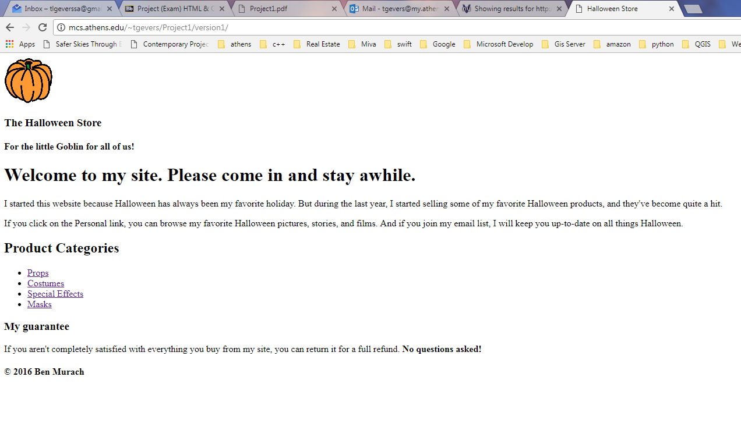

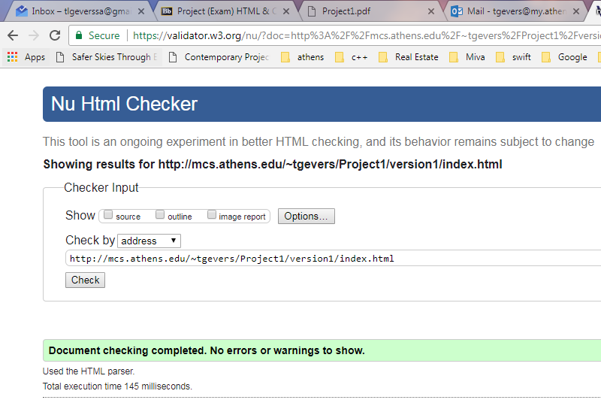

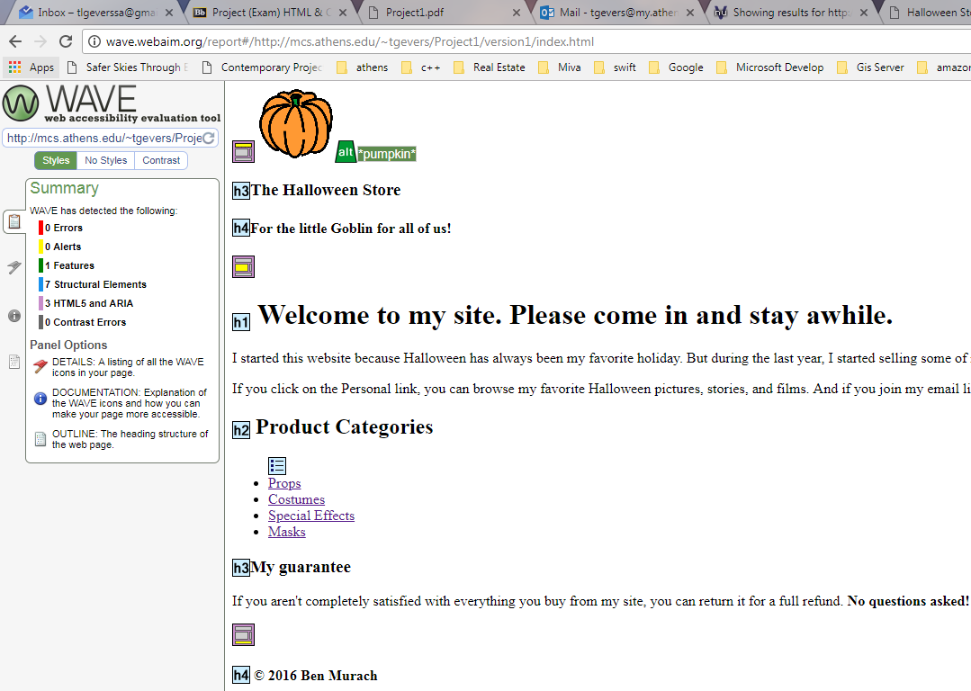

The summary from the wave tool included 0 errors, 0 alerts, 1 features, 7 structural elements, 3 HTML 5 and ARIA as well as 0 contrast errors.

**Exercise 2 Format the home page**

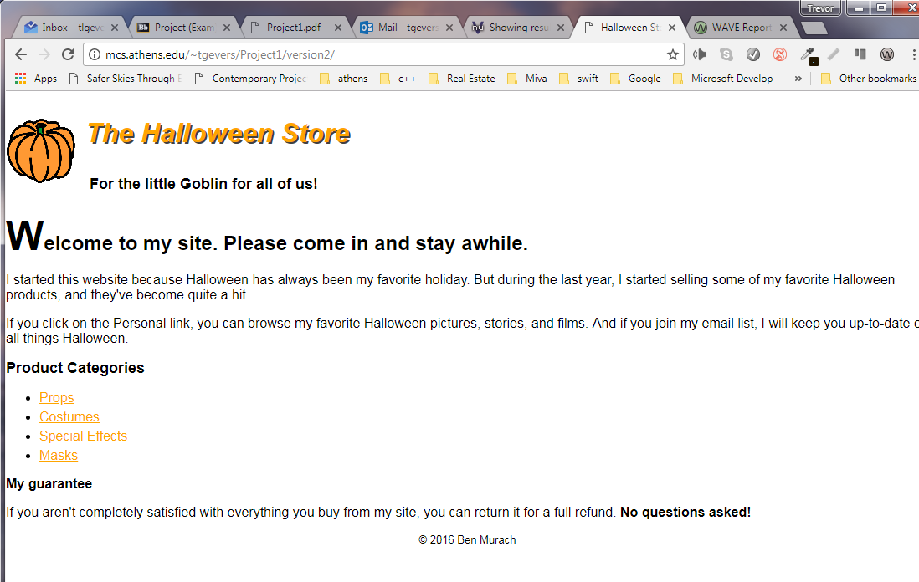

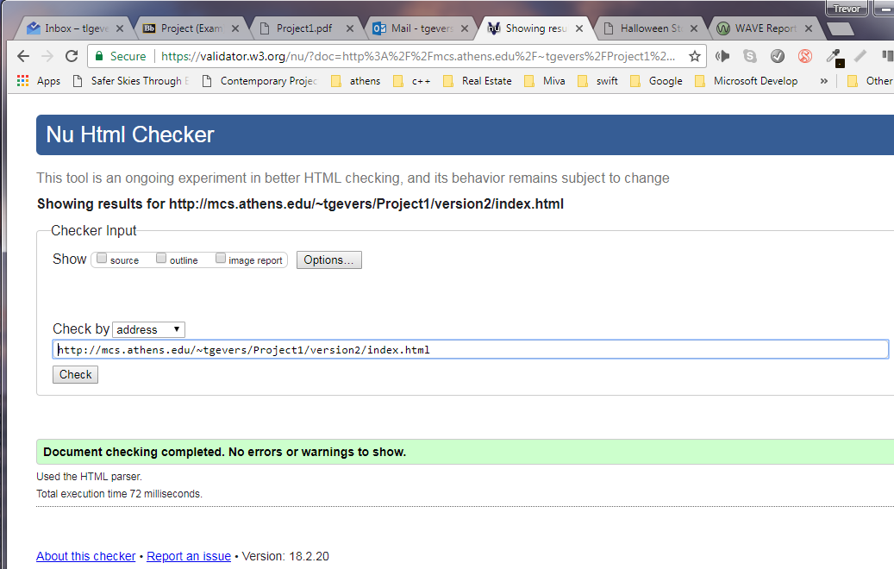

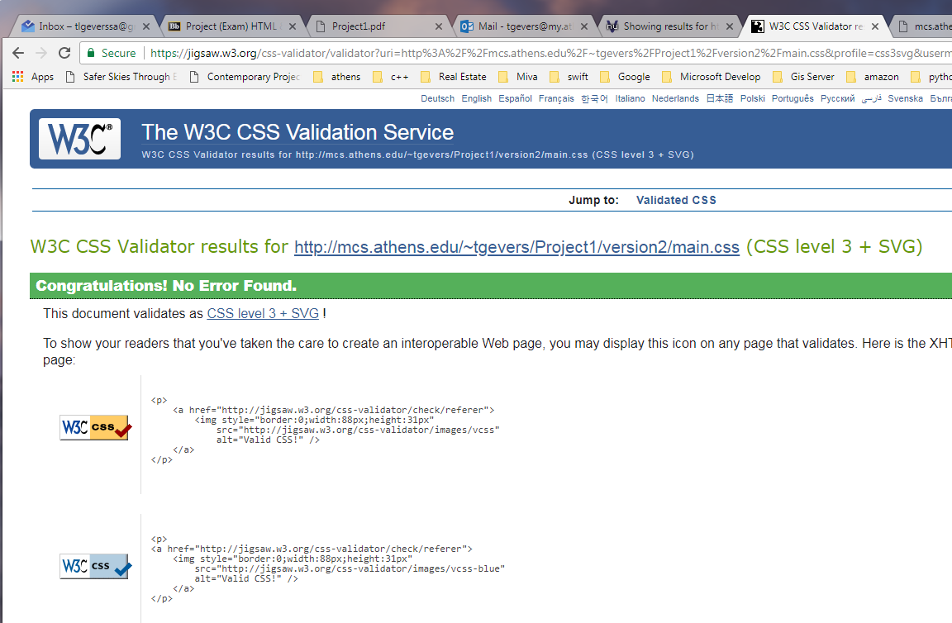

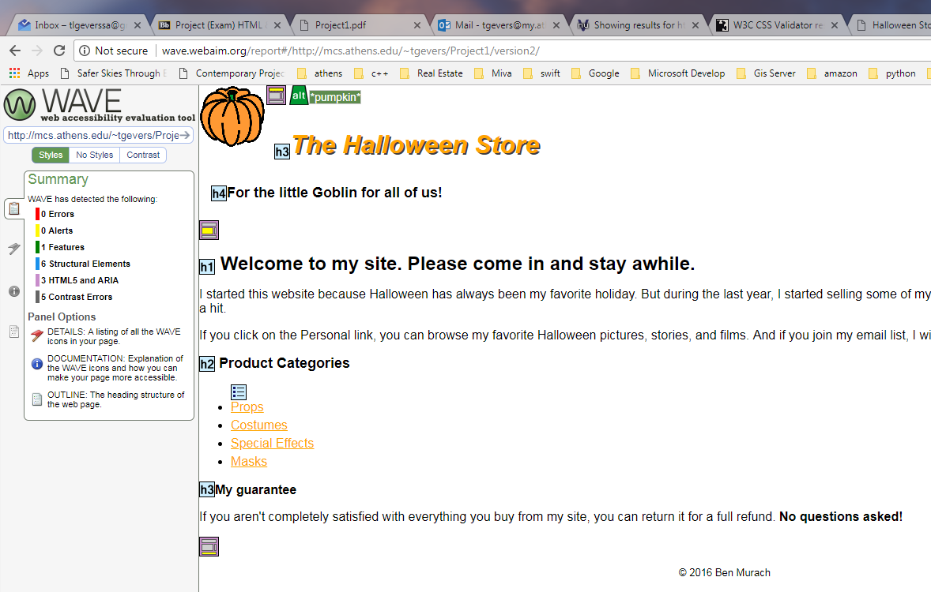

The summary from the wave tool included 0 errors, 0 alerts, 1 feature, 6 structural elements, 3 HTML5 and ARIA.

**Exercise 3 Enhance the home page formatting**

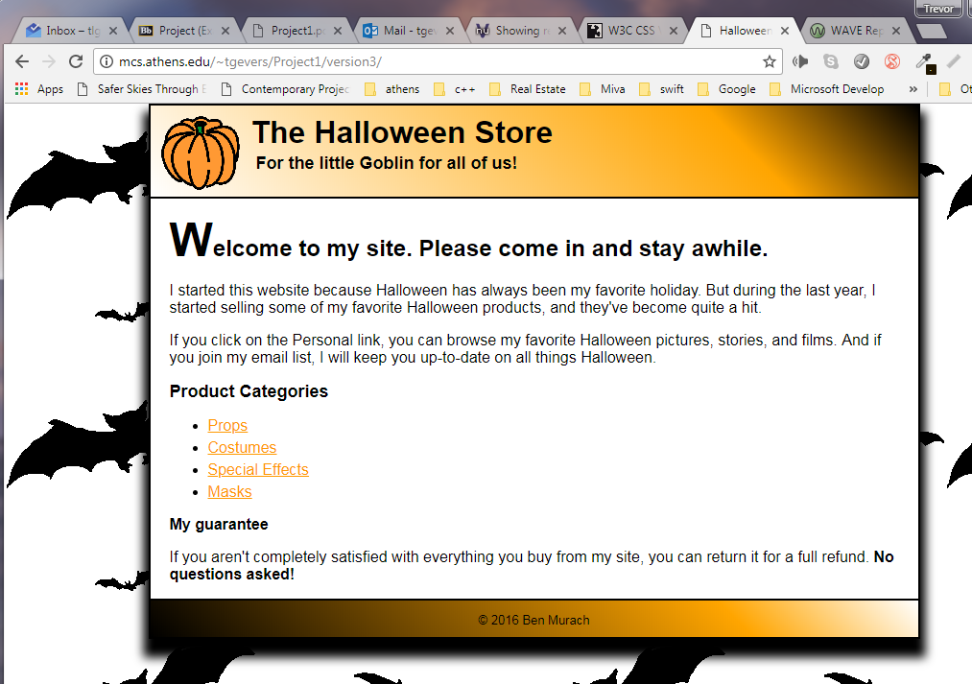

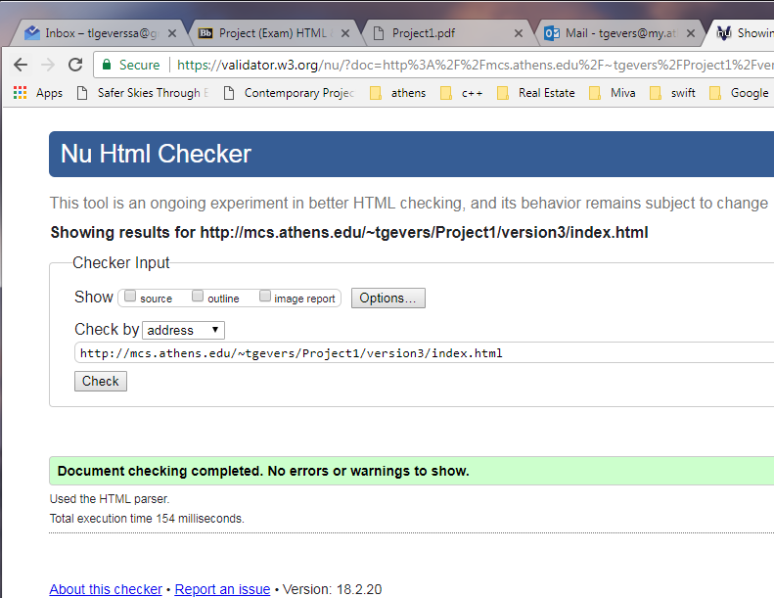

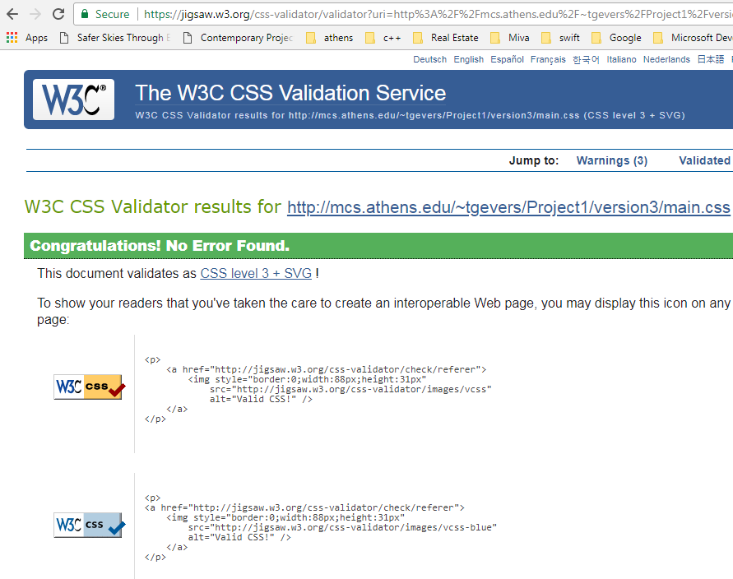

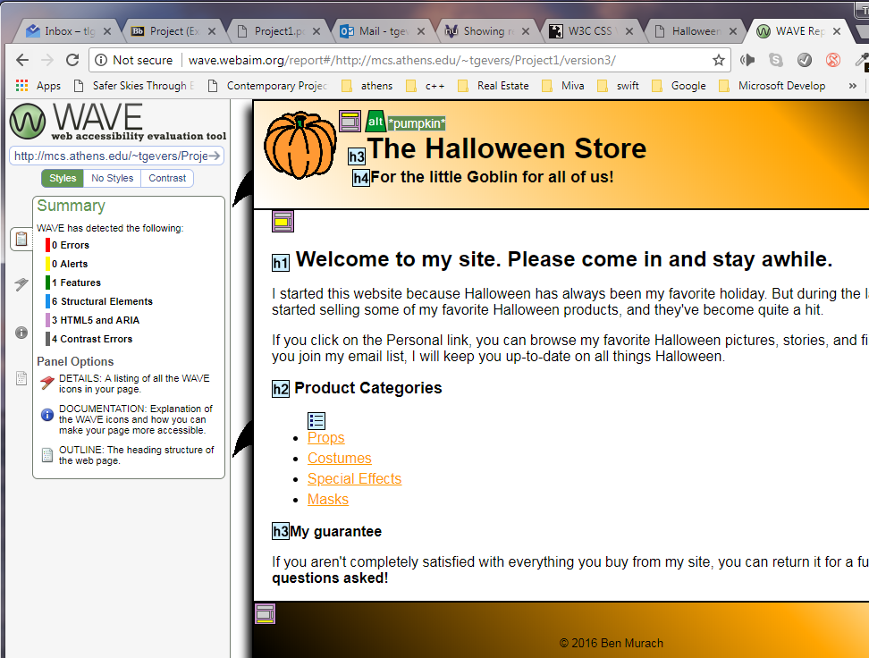

The summary of the wave tool anlysis included 0 errors, 0 alerts, 1 features, 6 structural elements, 3 HTML5 and ARIA and 4 Contrast Errors stating that the requested color orange is very low.

**Exercise 4 Use a 2-Column Layout**

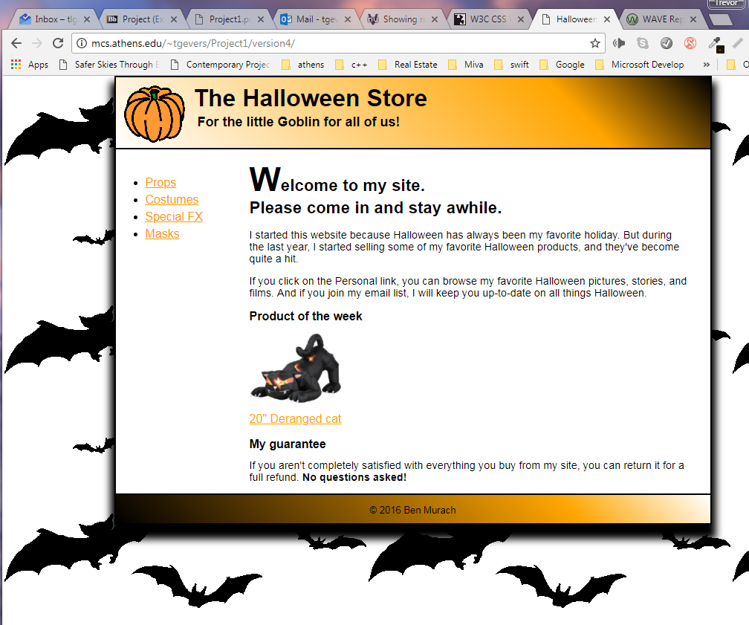

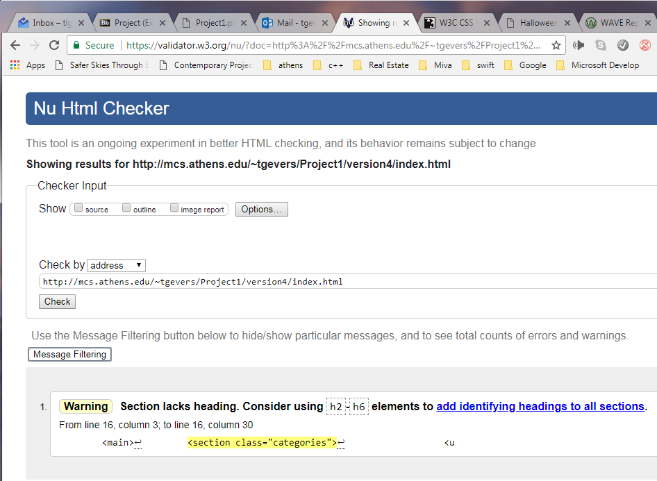

1 Warning was given given that I ommitted a heading within the section element as it was not required or needed.

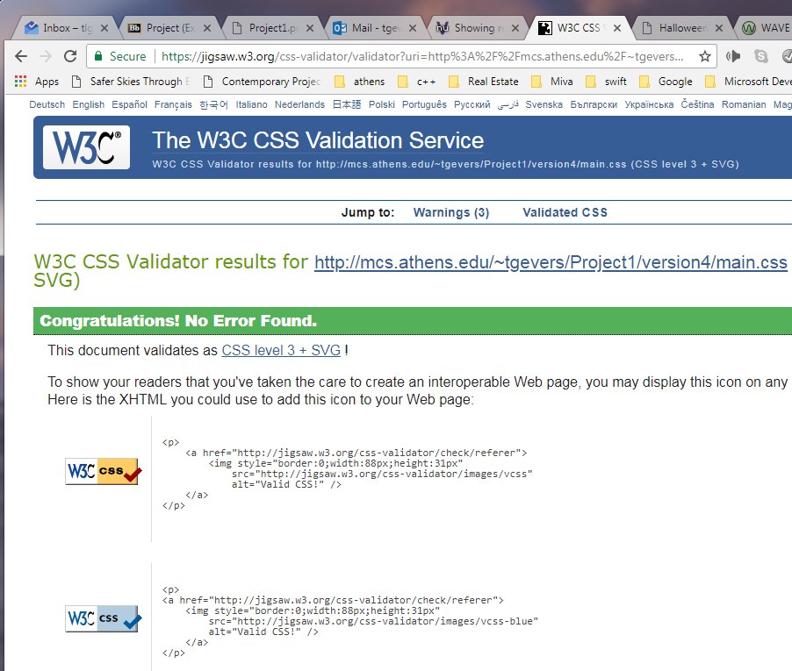

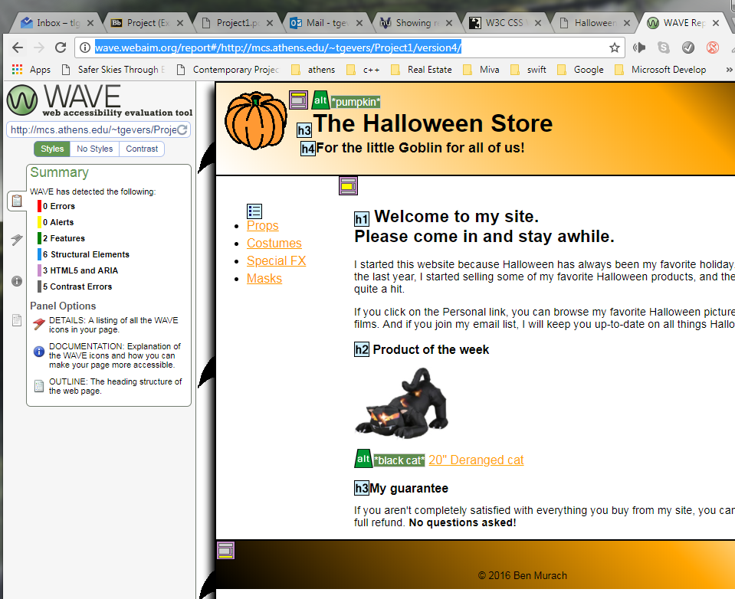

The summary of the wave analysis tool provided 0 errors, 0 alerts, 2 features, 6 structural elements, 3 HTML5 and ARIA as well as 5 contrast errors stating that the orange is of too lower contrast.

Exercise 5 Add two navigation menus

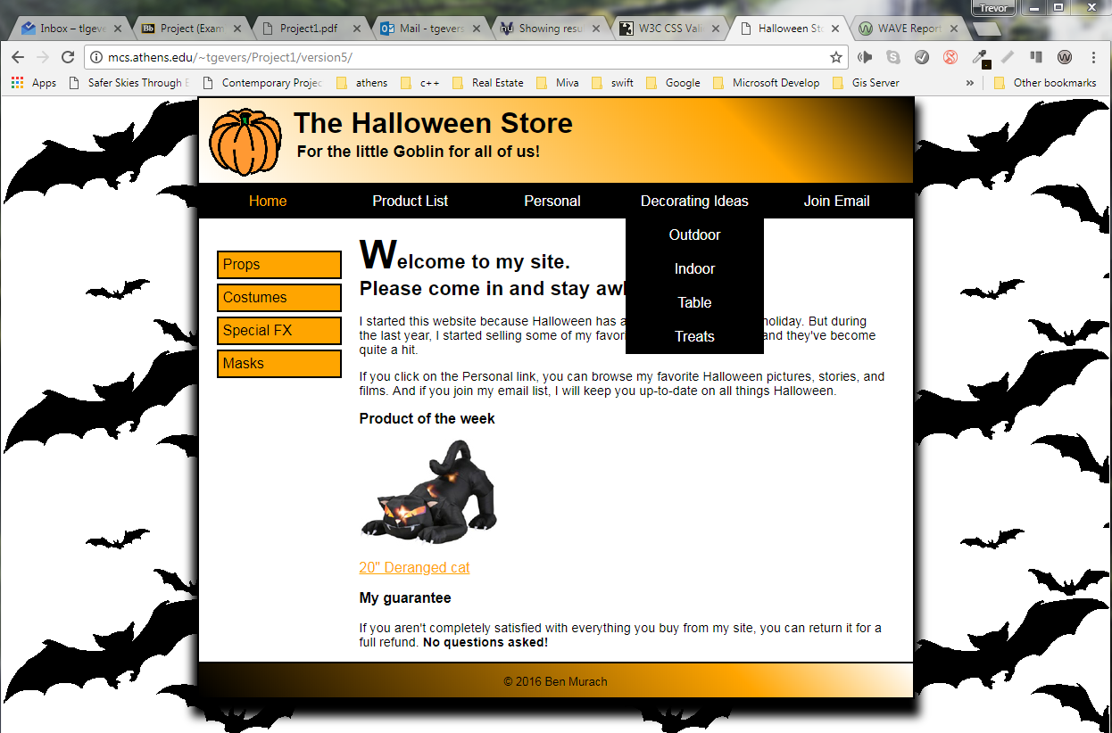

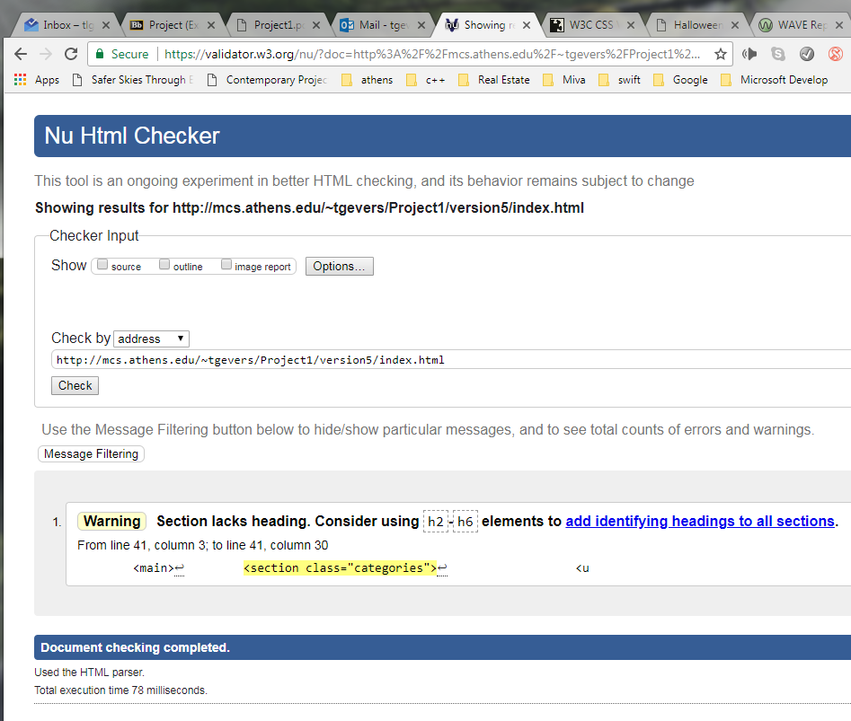

1 Warning was given given that I ommitted a heading within the section element as it was not required or needed.

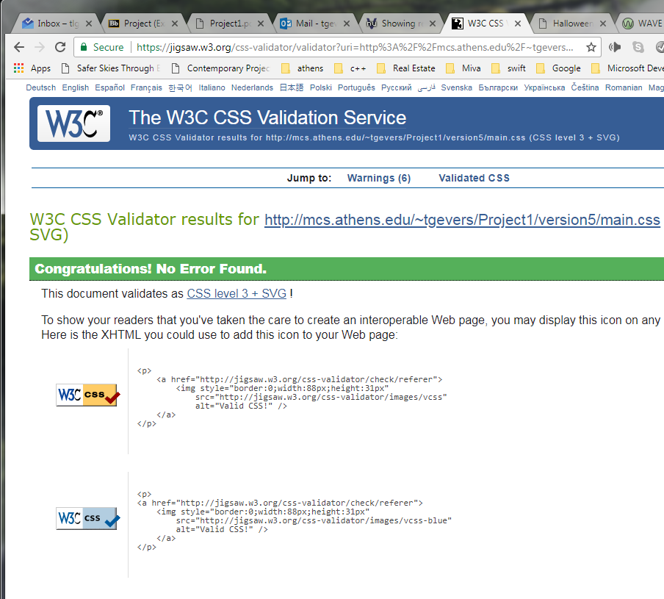

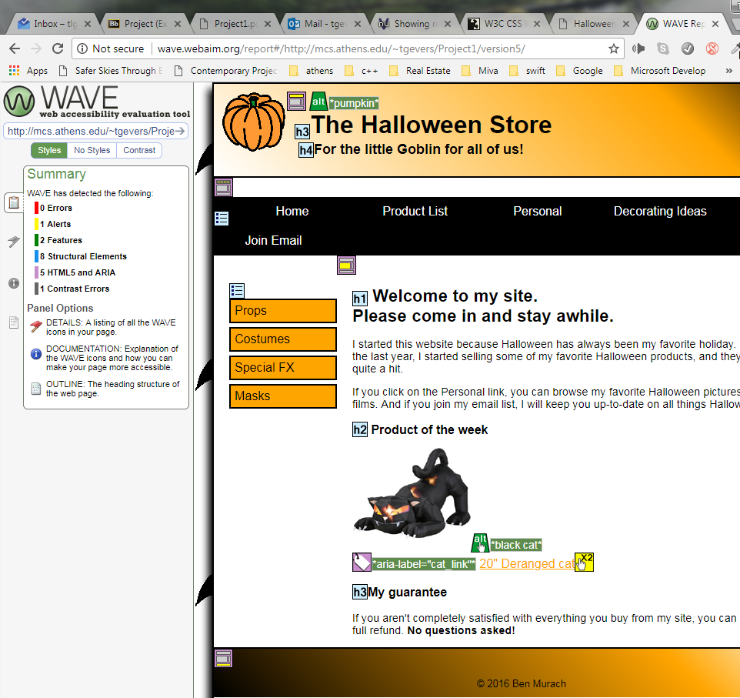

The wave analysis tool summary included 0 Errors, 1 Alert highlighting that I have a clickable link and image that link to the same page, it said it was redundant, I prefer to provide both links.

**Exercise 6 Responsive Web Design**

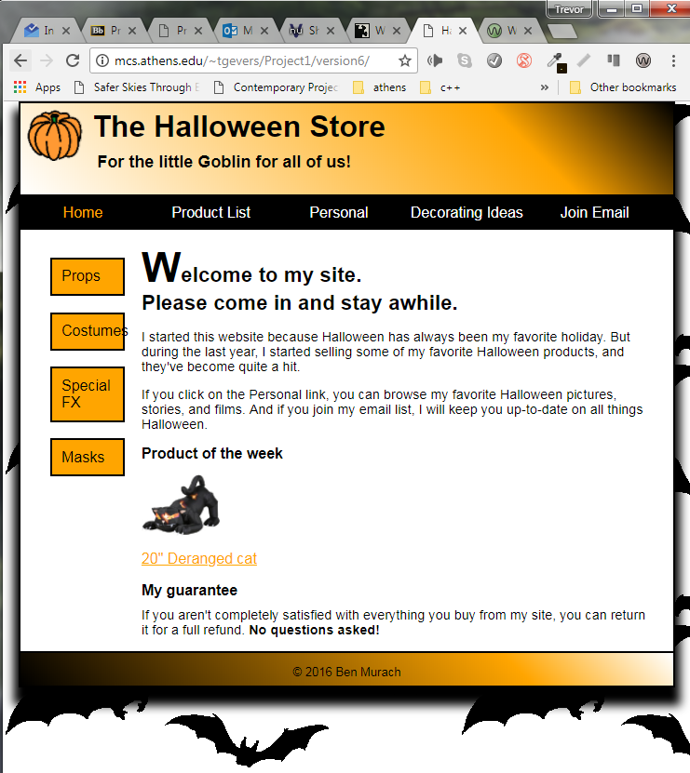

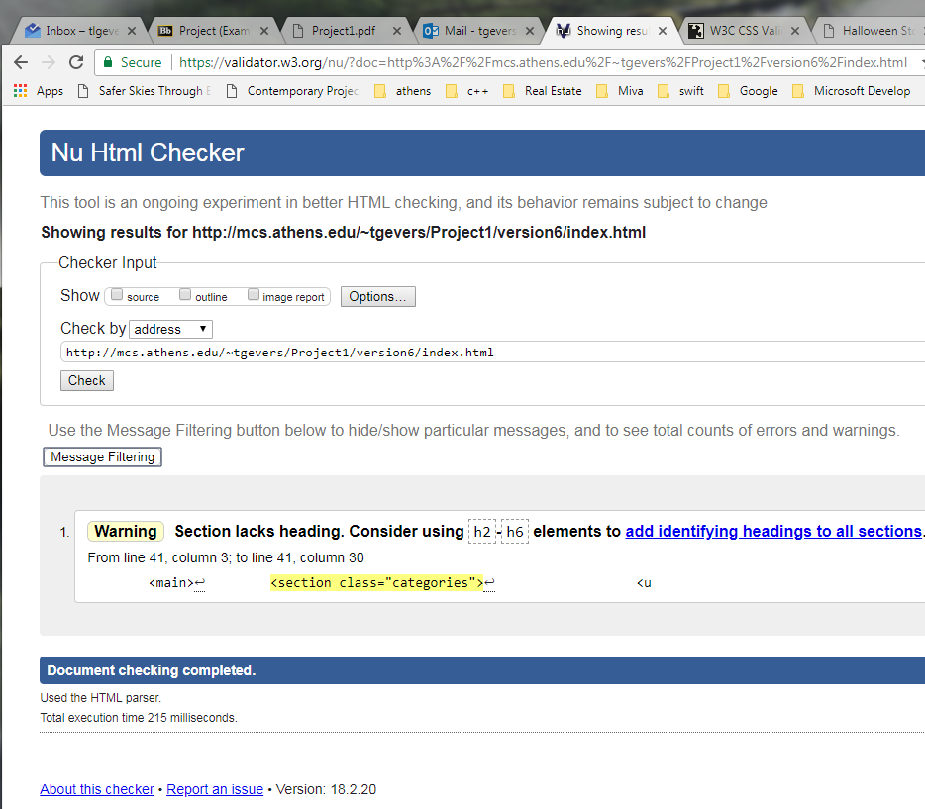

1 Warning was given given that I ommitted a heading within the section element as it was not required or needed.

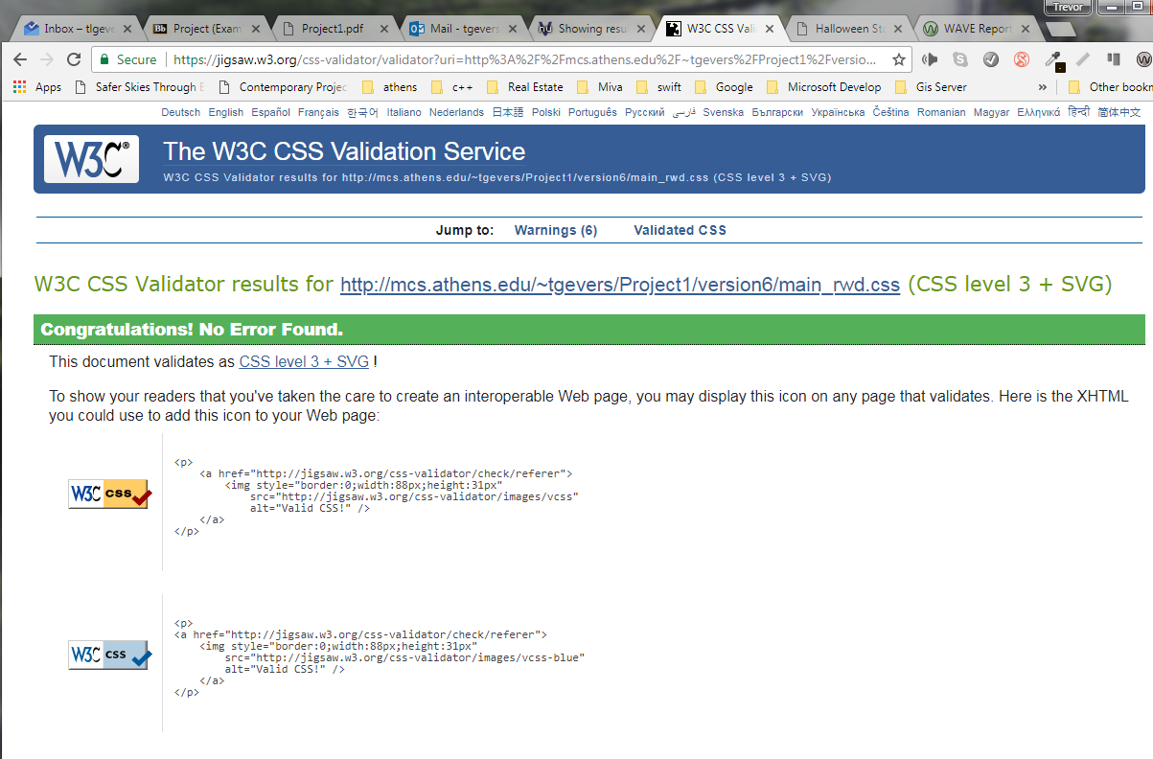

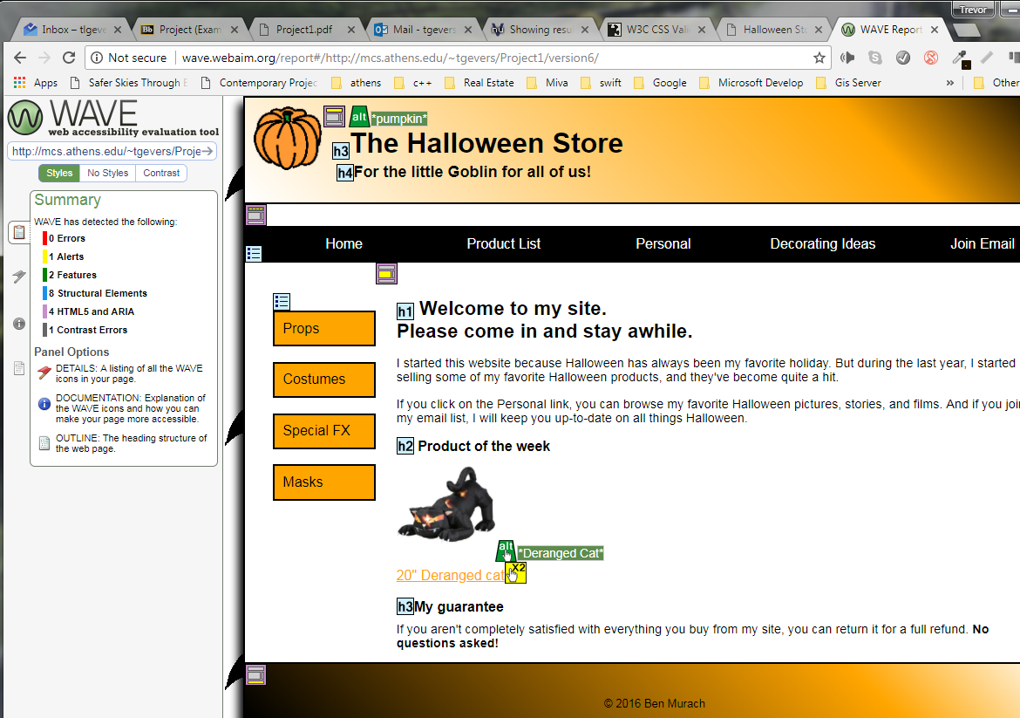

The summary included 0 Errors, , 1 Alert highlighting that I have a clickable link and image that link to the same page, it said it was redundant, I prefer to provide both links. As well as 2 Features, 8 Structural Elements, 4 HTML5 and ARIA.

**Specifications for a media query for a tablet in portrait orientation**

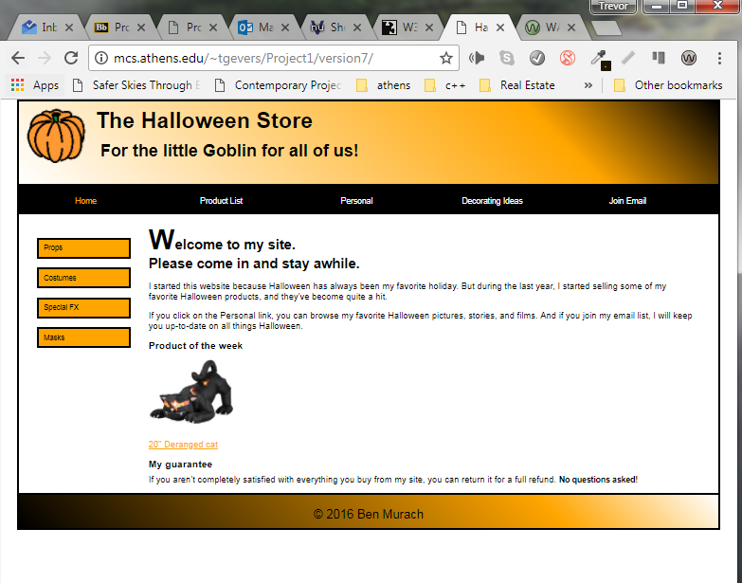

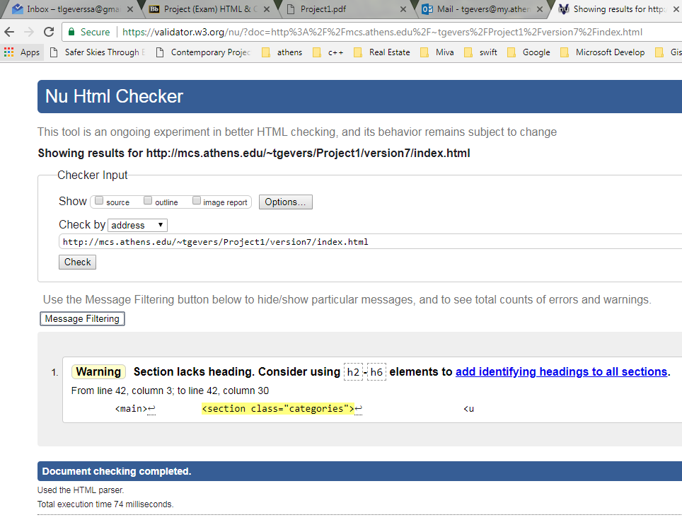

1 Warning was given given that I ommitted a heading within the section element as it was not required or needed.

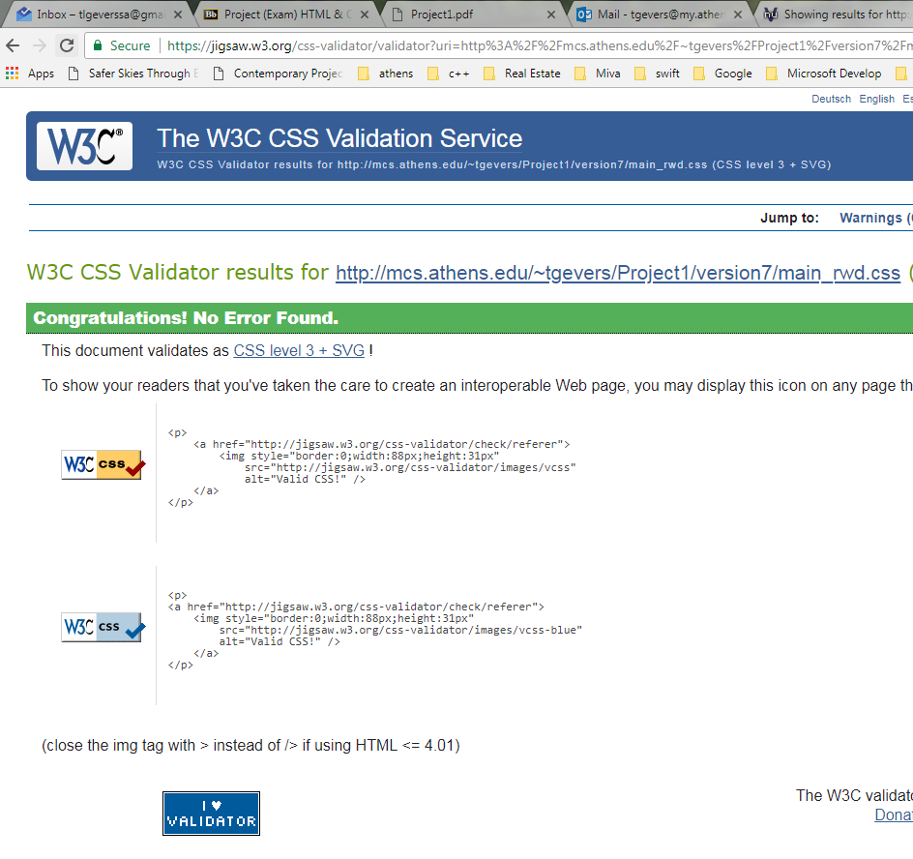

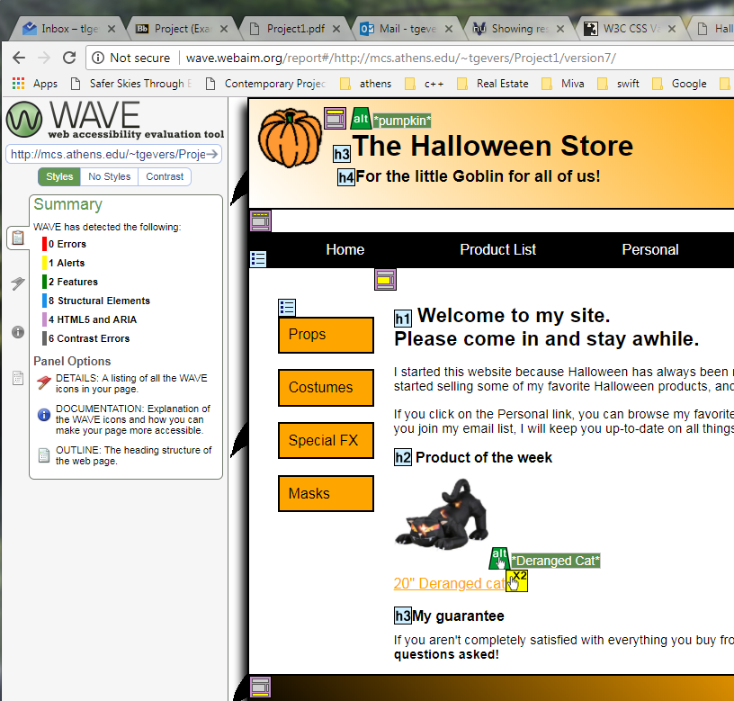

The summary included 0 Errors, , 1 Alert highlighting that I have a clickable link and image that link to the same page, it said it was redundant, I prefer to provide both links. As well as 2 Features, 8 Structural Elements, 4 HTML5 and ARIA.

Specifications for a media query for a mobile phone in landscape orientation

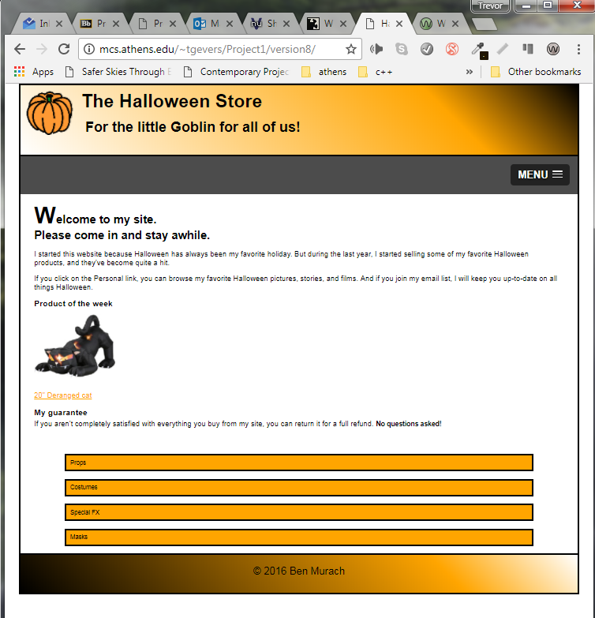

Additional screen shot of menu expanded.

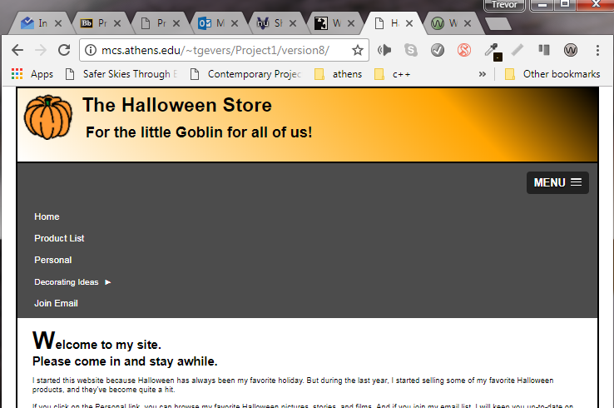

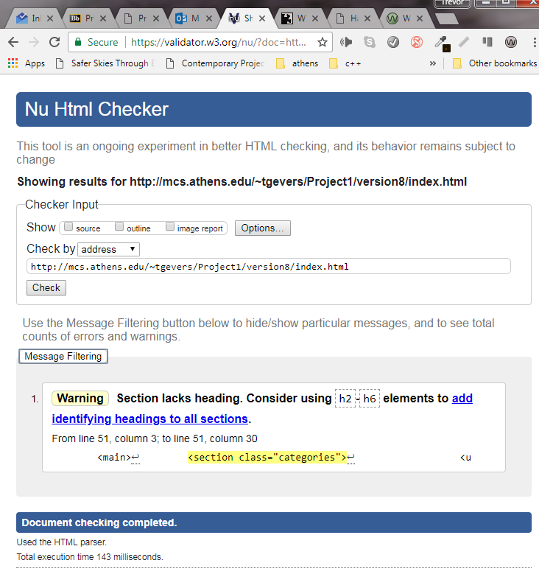

1 Warning was given given that I ommitted a heading within the section element as it was not required or needed.

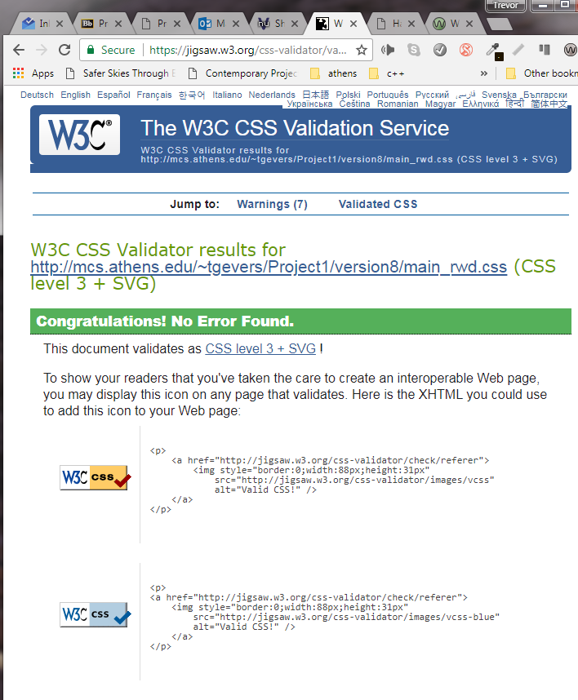

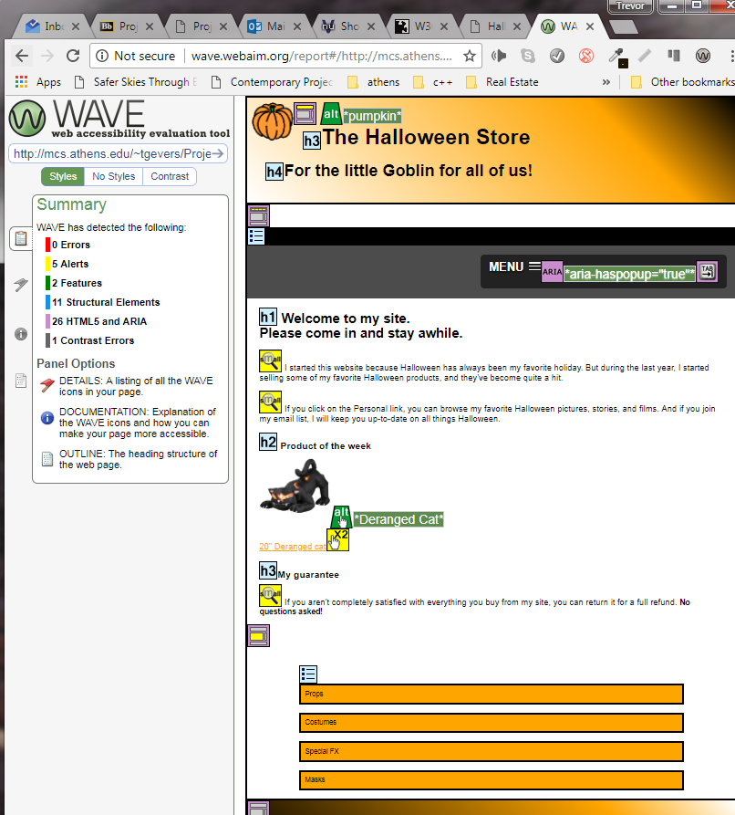

The summary of the analysis included 0 errors, 5 alerts including a redundant link issue with an image and text as a link to the same page, and then very small text given that the font -size is being scaled down to 90%. 2 Features, 11 Structural Elements, 26 HTML5 and ARIA and 1 Contrast Error for the use of orange on a white background.

**Specifications for a media query for a mobile phone in portrait orientation**

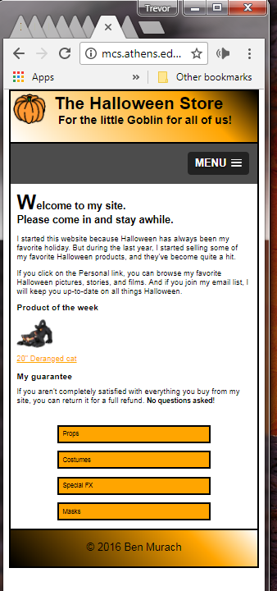

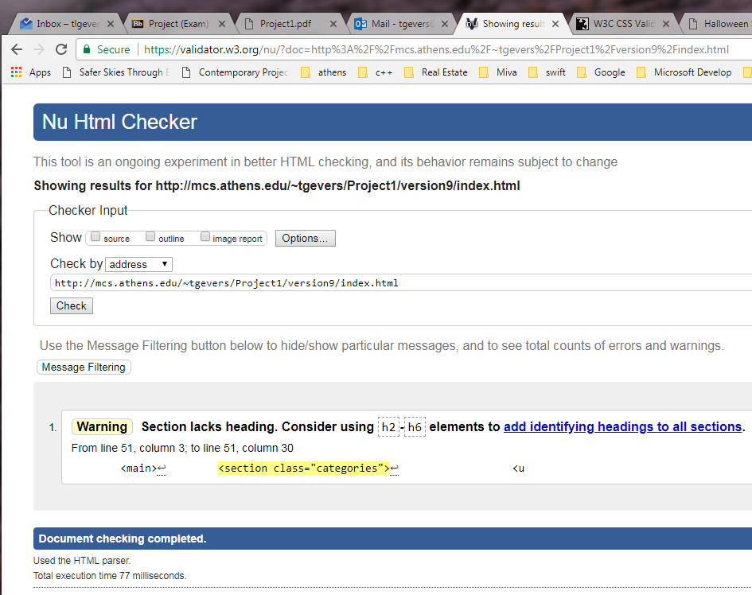

1 Warning was given given that I ommitted a heading within the section element as it was not required or needed.

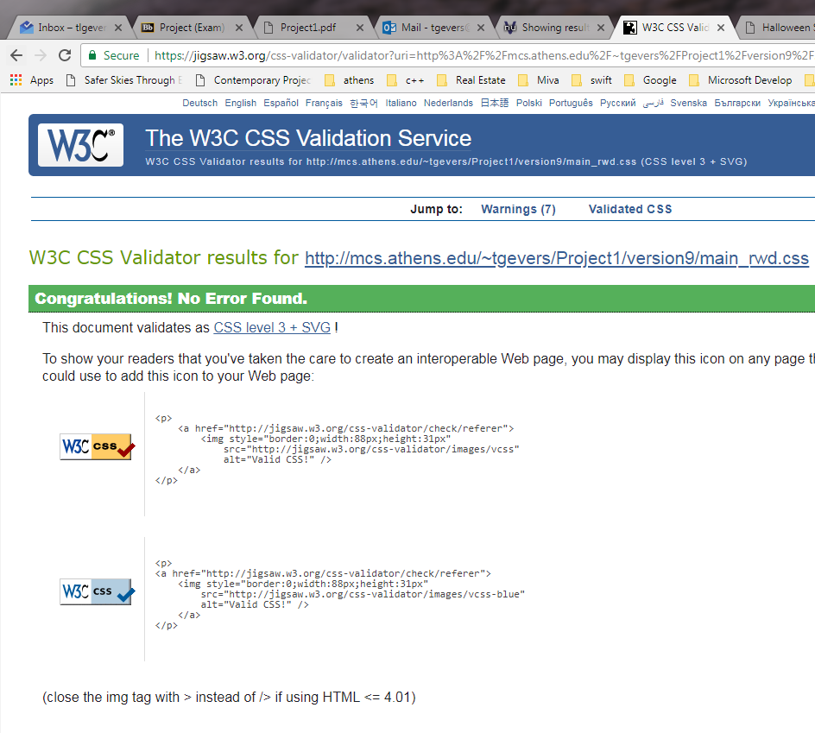

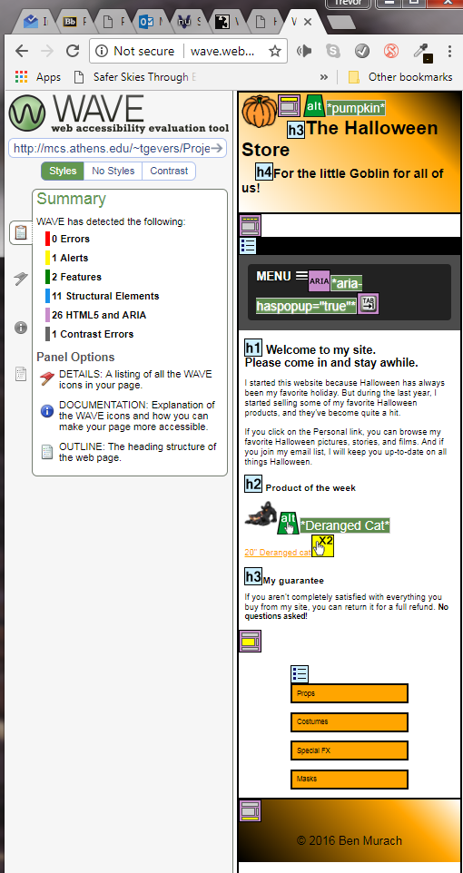

The summary included 0 Errors, 1 Alerts for a redundant link issue with an image and text as a link to the same page, 2 Features, 11 Structural Elements, 26 HTML5 and ARIA and 1 Contrast Error for use of orange on a white background.

**Exercise 7 Create a product page**

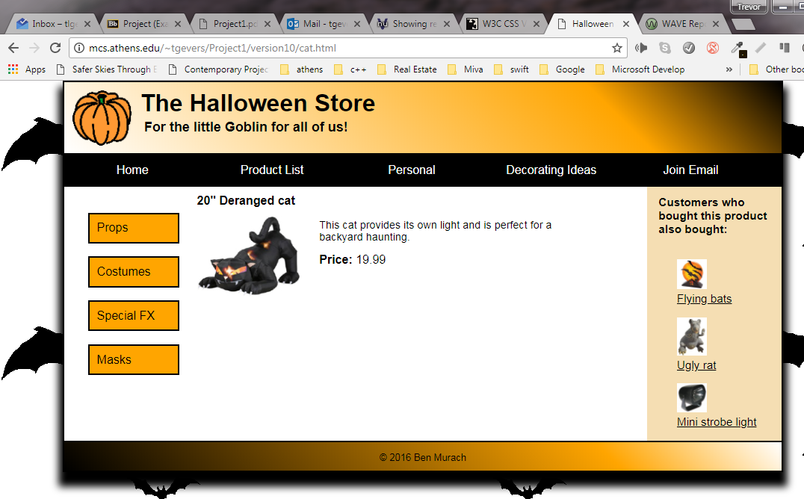

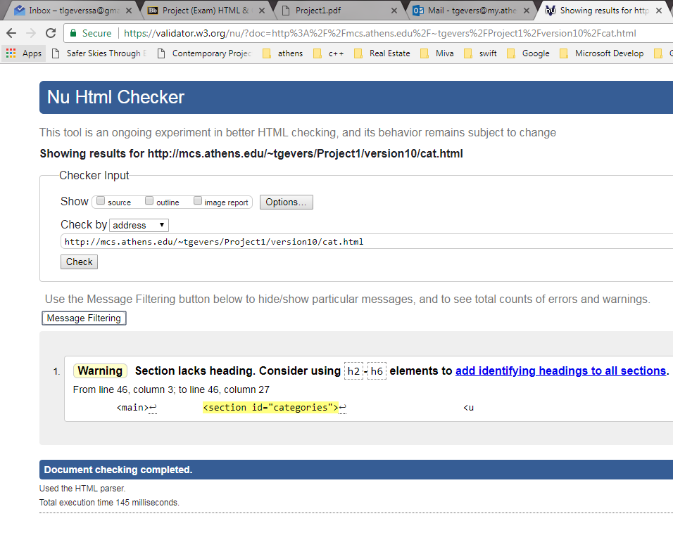

1 Warning was given given that I ommitted a heading within the section element as it was not required or needed.

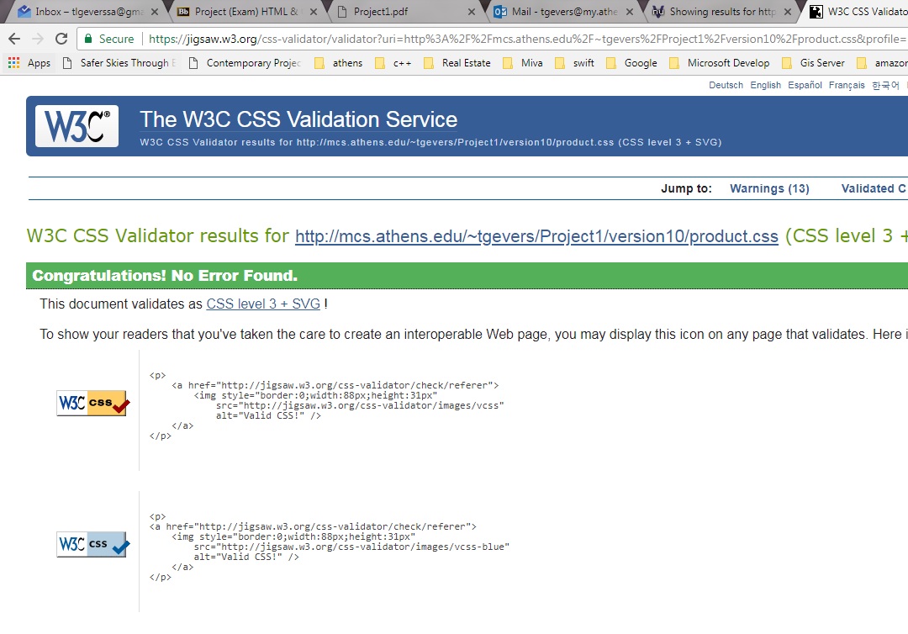

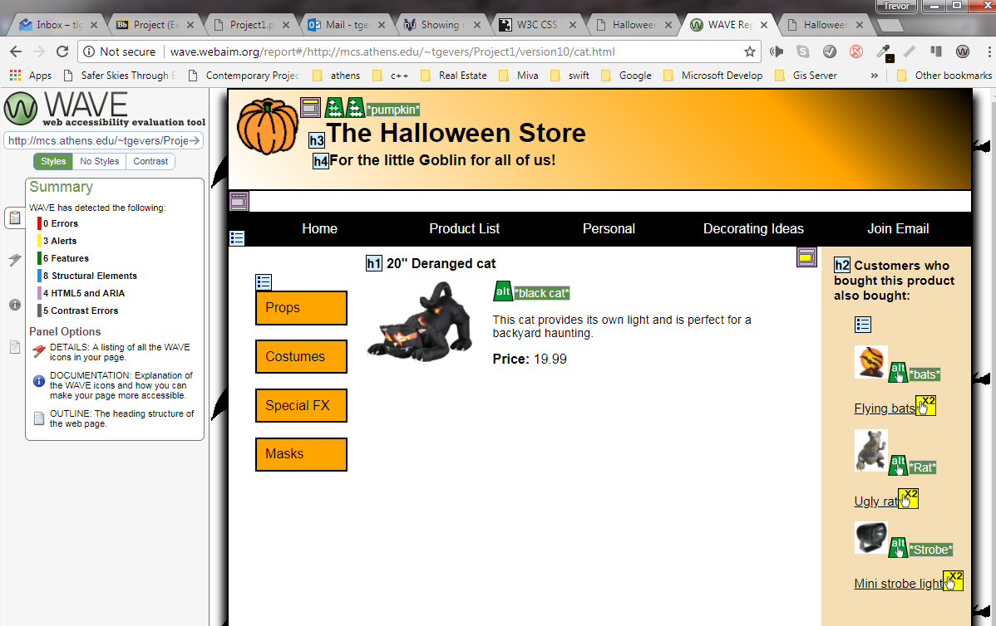

The sumary included 0 Errors and 3 Alerts with the use of links next to an image that too is linked to the same page. As well as 6 Features, 8 Structural Elements, 4 HTML5 and ARIA and 5 Contrast Errors with the use of white on a black background, should the css fail to load the text will default to black given that the white is only specified within the css file.

**8 Create a page that uses a table**

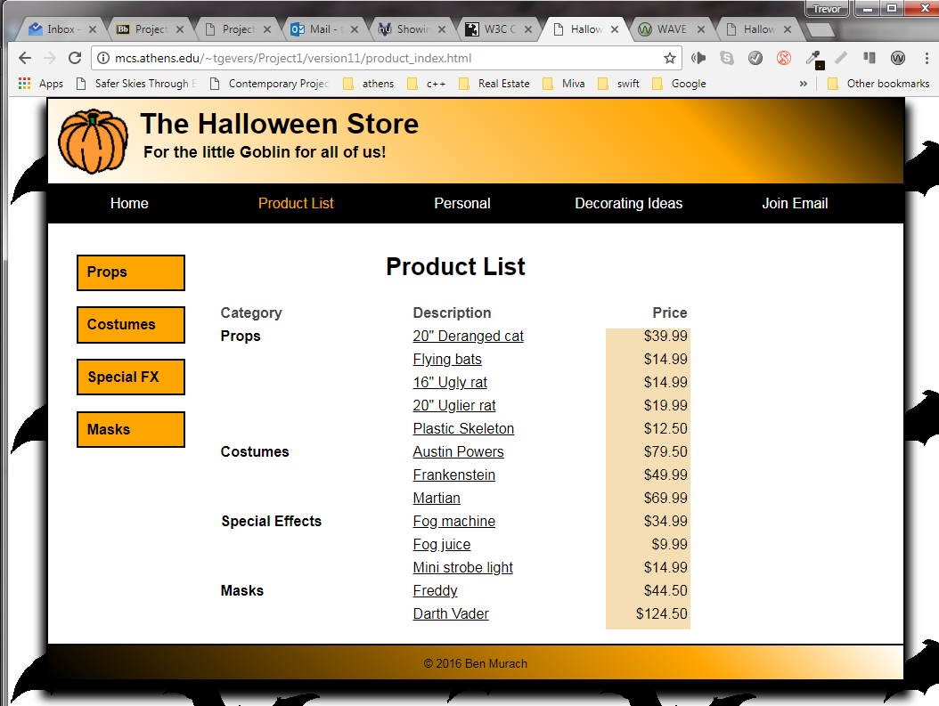

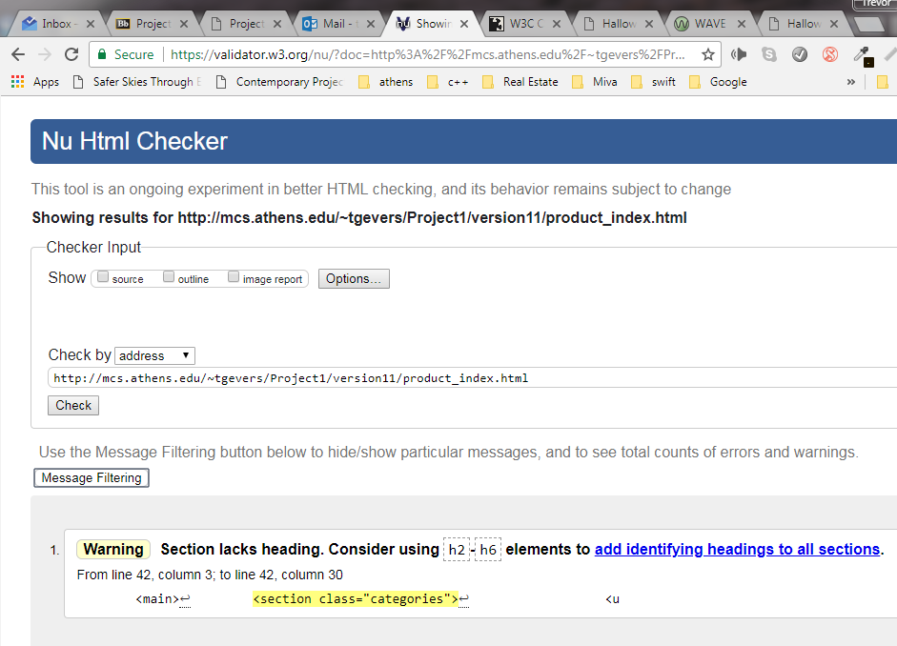

1 Warning was given given that I ommitted a heading within the section element as it was not required or needed.

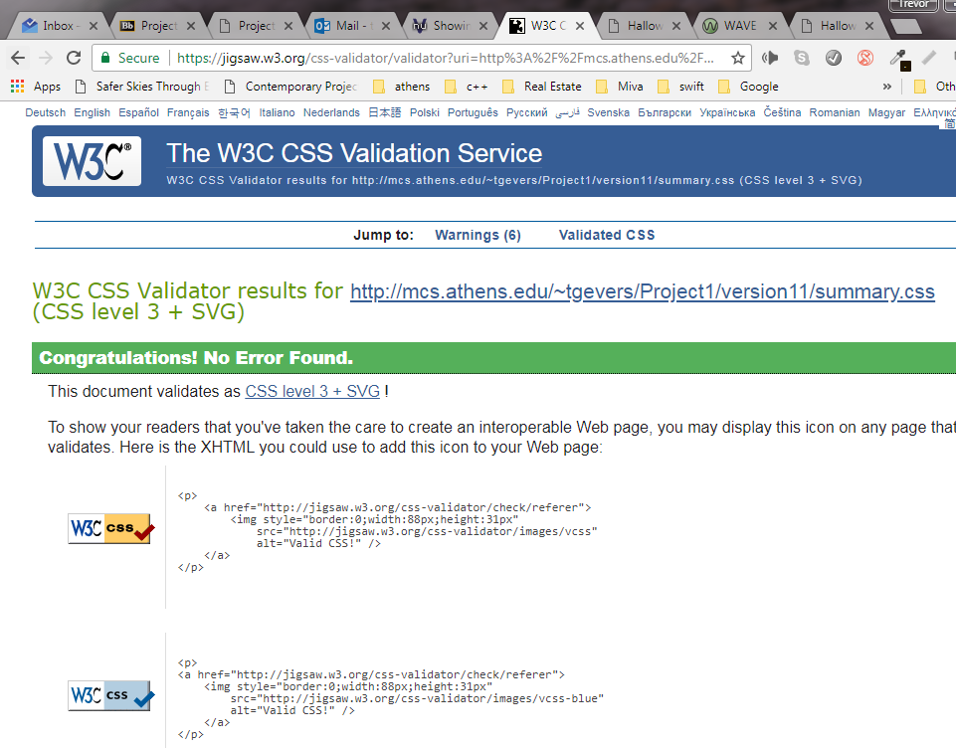

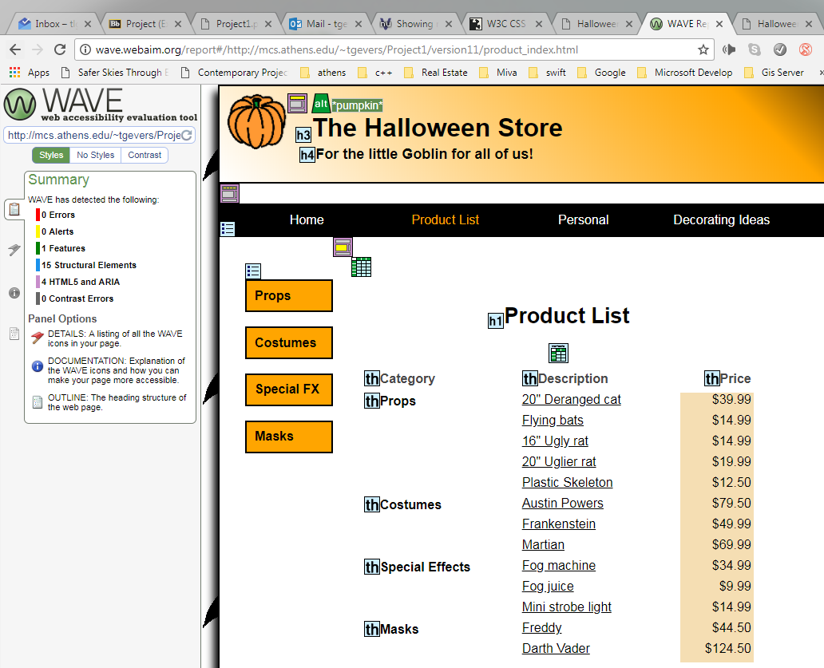

The summary included 0 Errors, 0 Alerts, 1 Feature, 15 Structural Elements, 4 HTML5 and ARIA and 0 Contrast Errors.

**9 Create a page that uses a form**

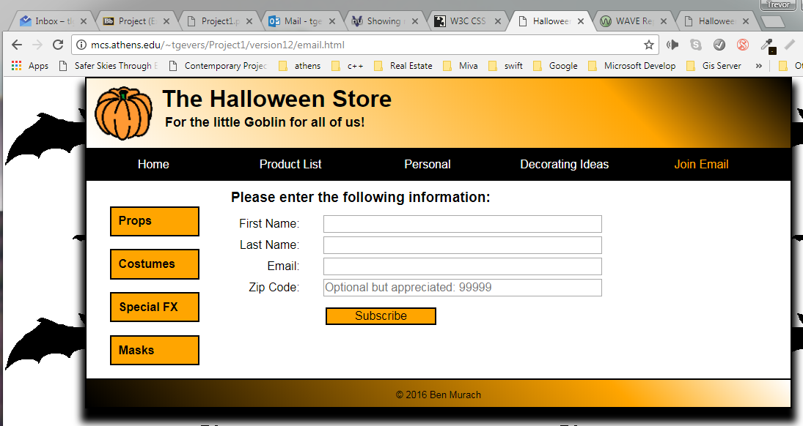

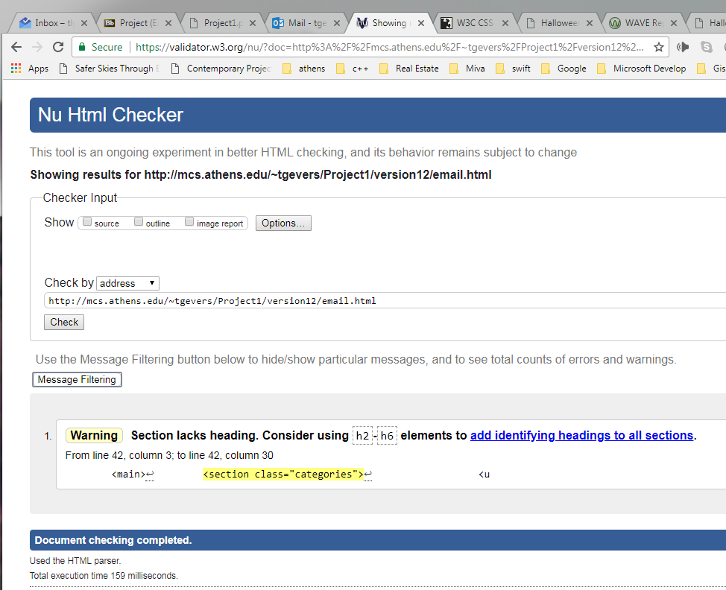

1 Warning was given given that I ommitted a heading within the section element as it was not required or needed.

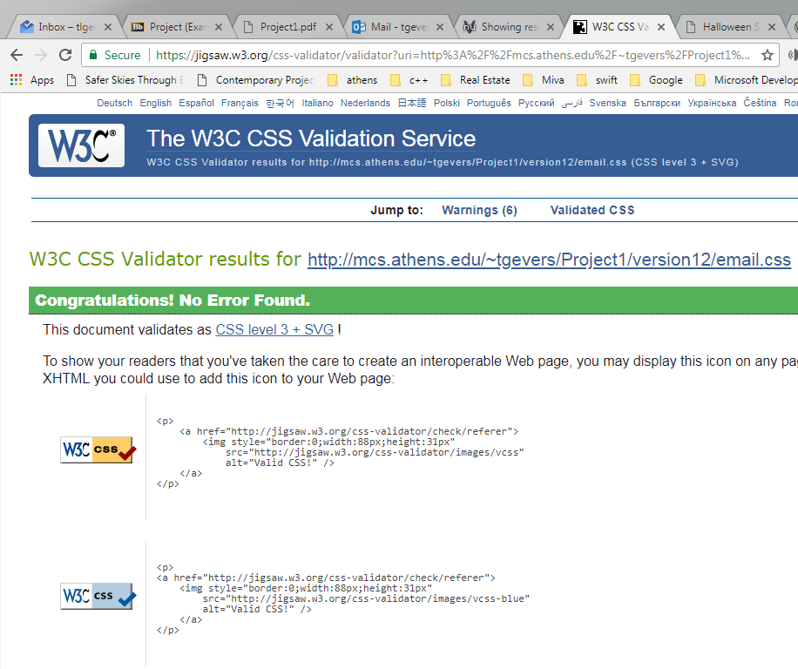

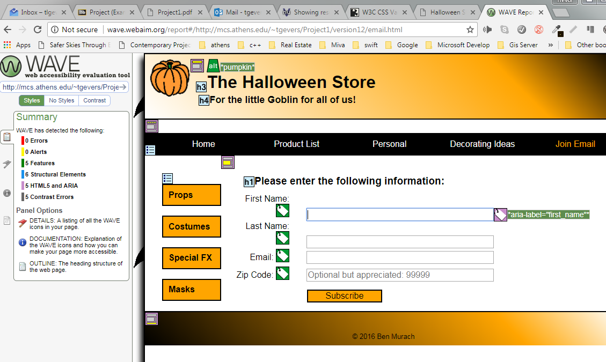

The summary included 0 Errors, 0 Alerts, 5 Features, 6 Structural Elements, 5 HTML5 and ARIA, 5 Contrast Errors with the use of the white text in the menu.

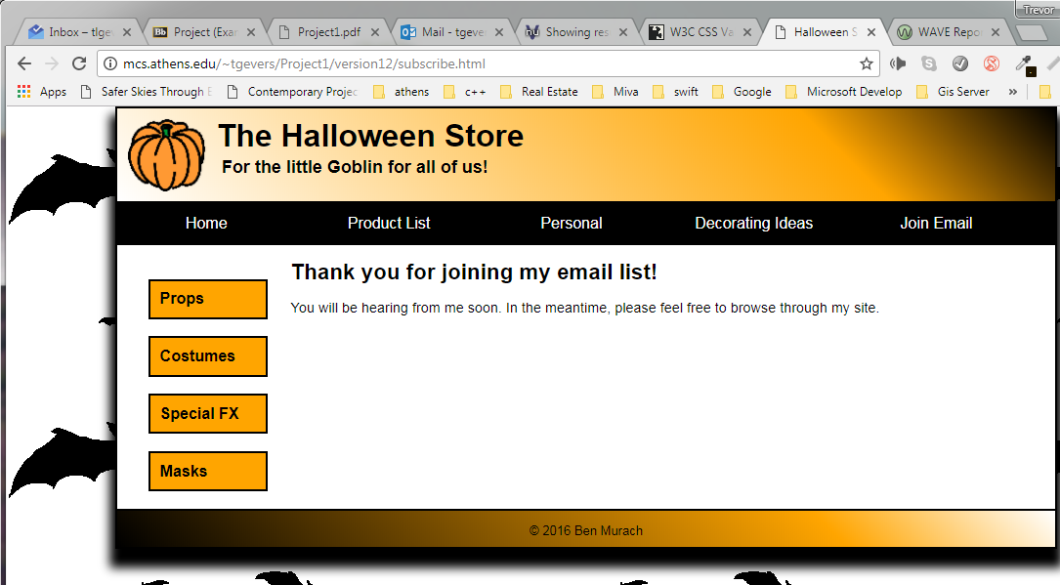

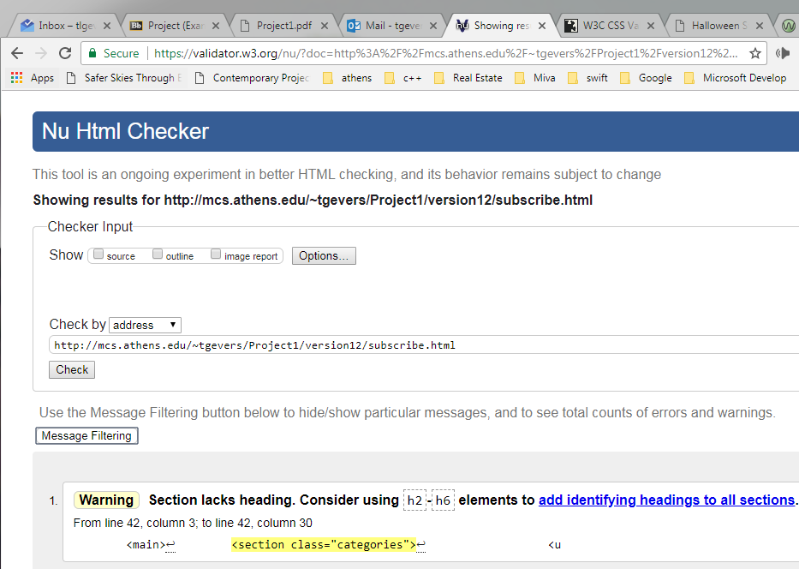

1 Warning was given given that I ommitted a heading within the section element as it was not required or needed.

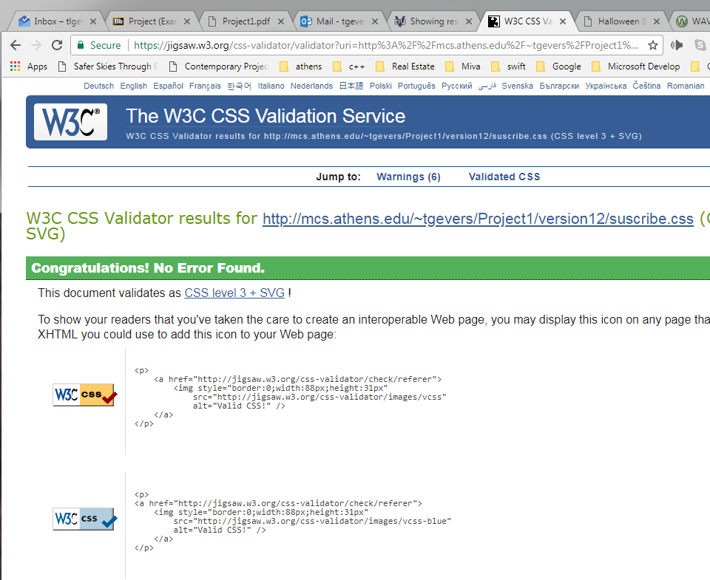

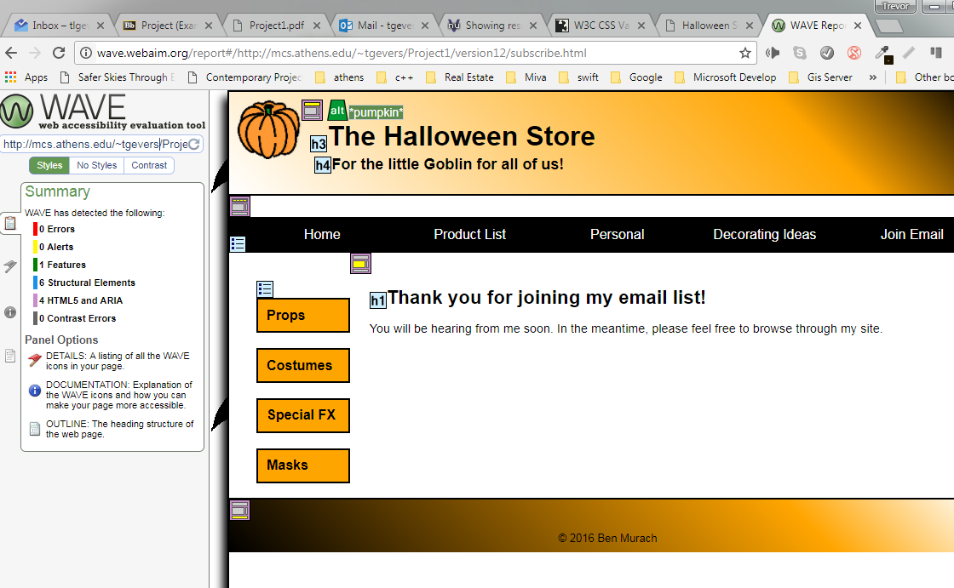

The summary included 0 Errors, 0 Alerts, 1 Features, 6 Structural Elements, 4 HTML5 and ARIA and 0 Contrast Errors.

**10 Create a page that uses a video**

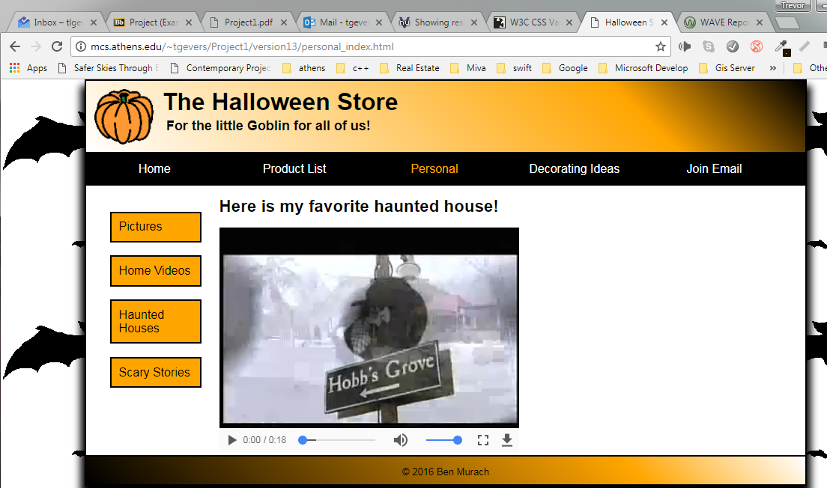

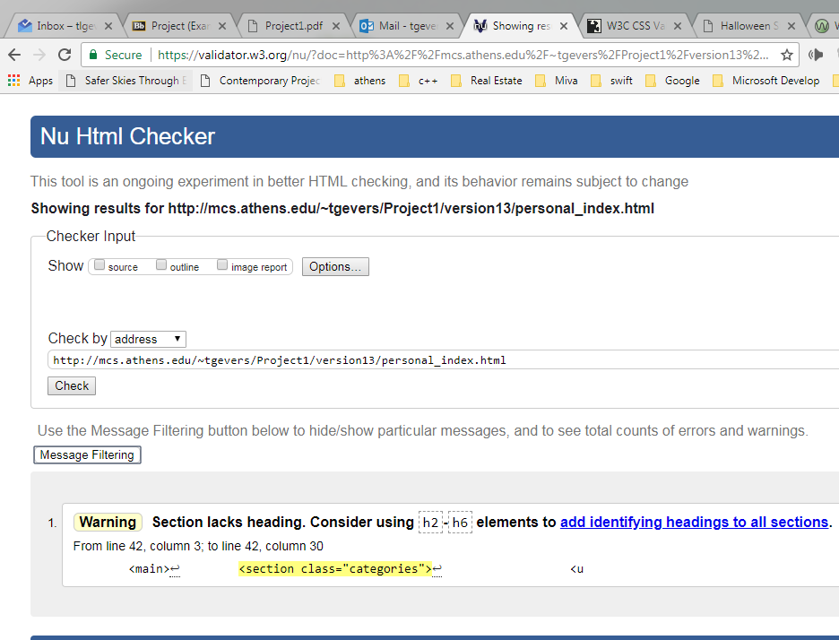

1 Warning was given given that I ommitted a heading within the section element as it was not required or needed.

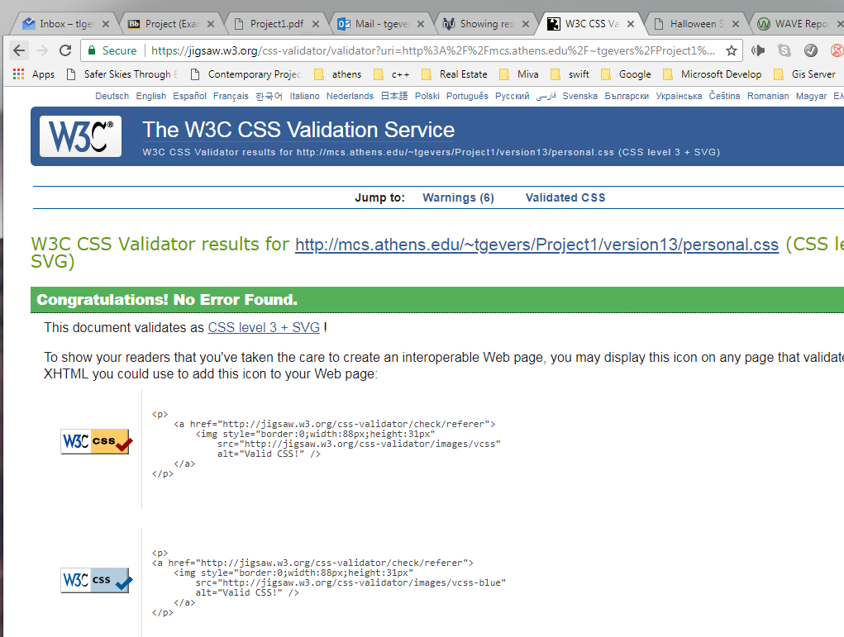

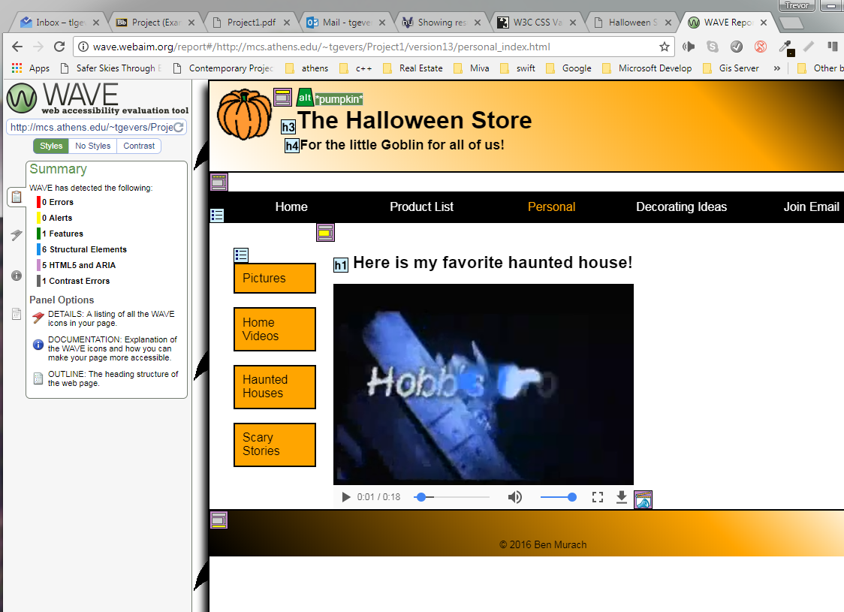

The summary included 0 Errors, 0 Alerts, 1 Feature, 6 Structural Elements, 5 HTML5 and ARIA and 0 Contrast Errors.

**11 Add an embedded font and a story and provide for printing the story**

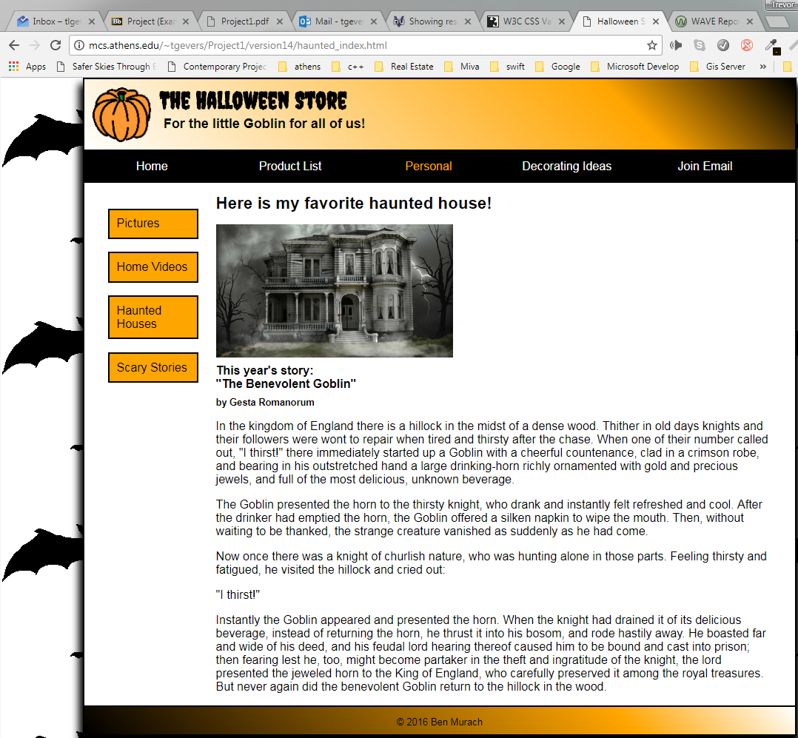

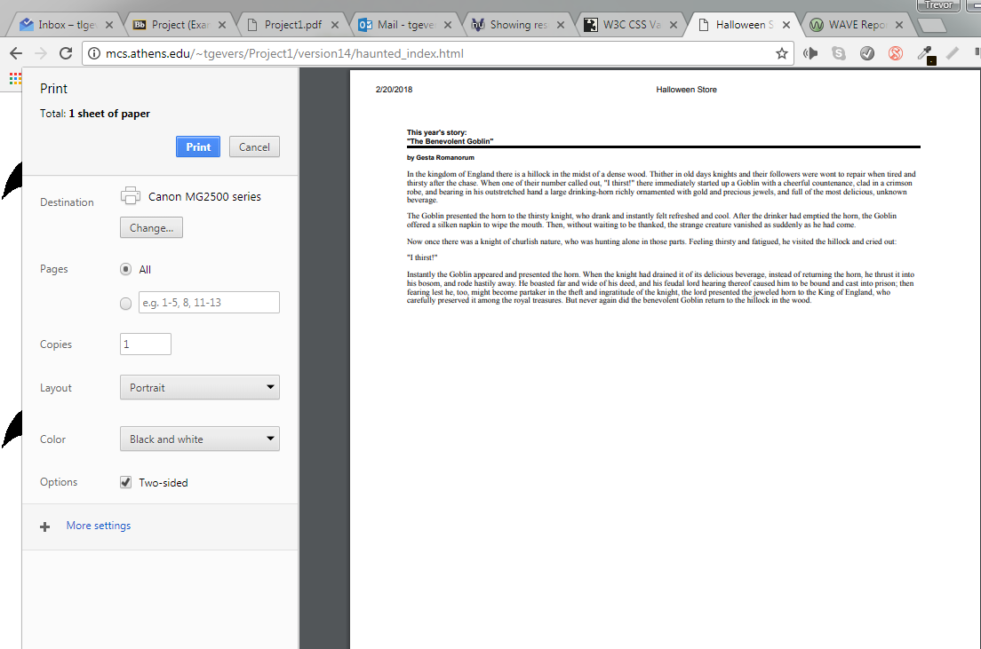

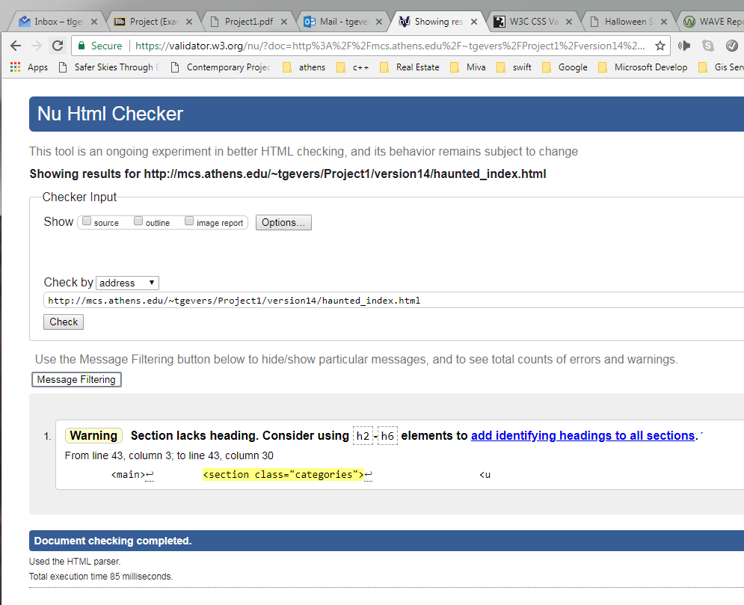

1 Warning was given given that I ommitted a heading within the section element as it was not required or needed.

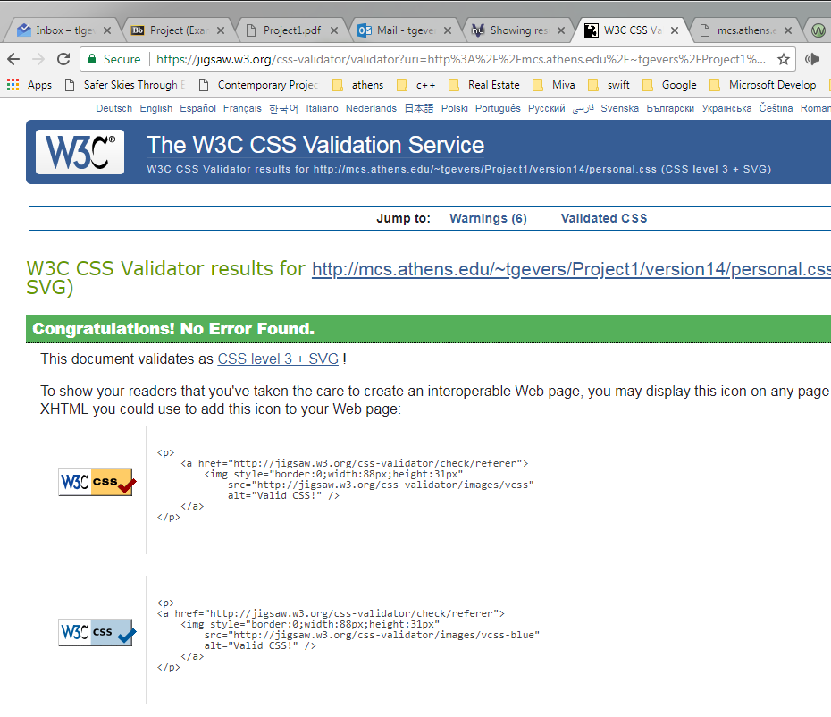

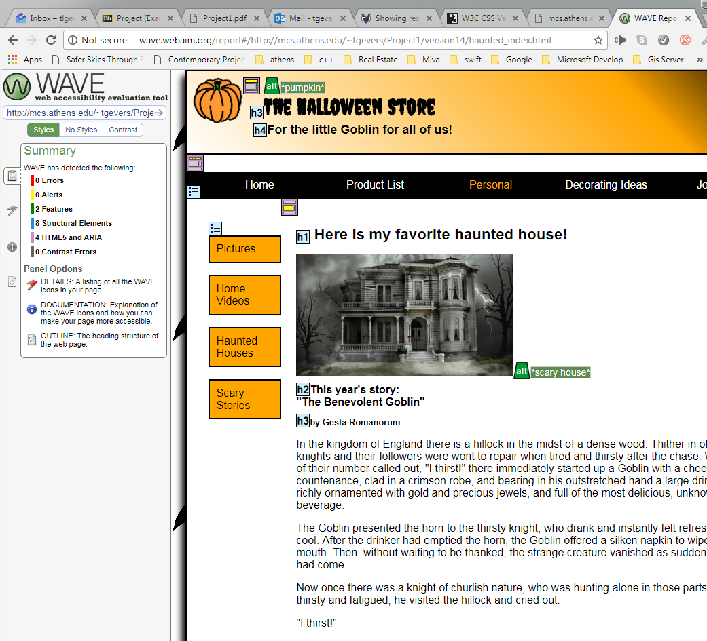

The summary included 0 Errors, 0 Alerts, 2 Features, 8 Structural Elements, 4 HTML5 and ARIA, 0 Contrast Errors.

**12 Add a transition and an animation**

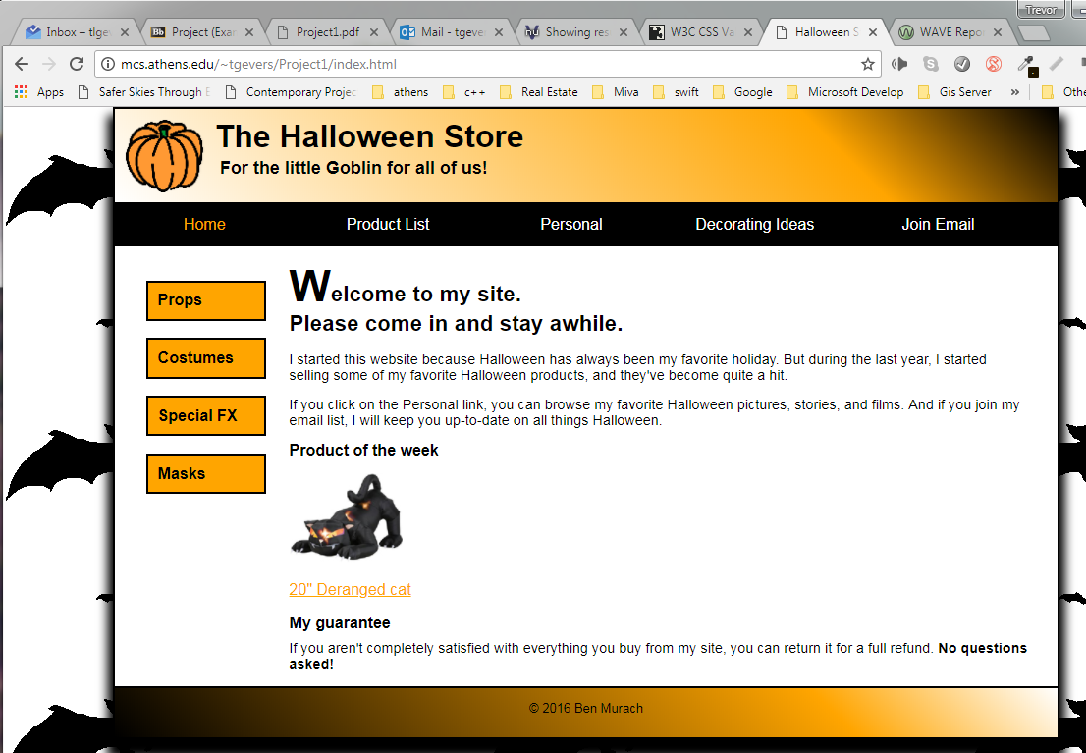

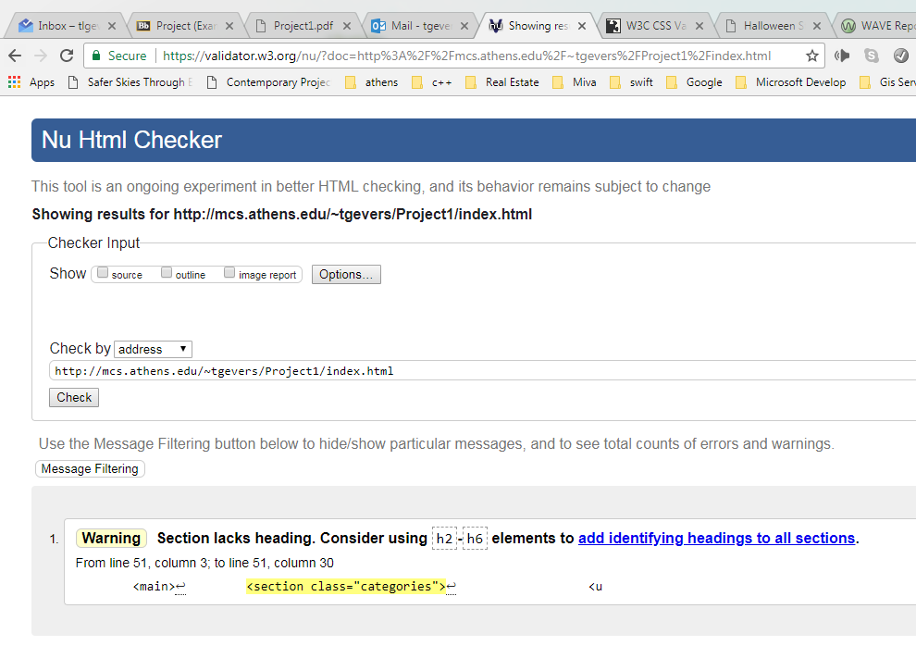

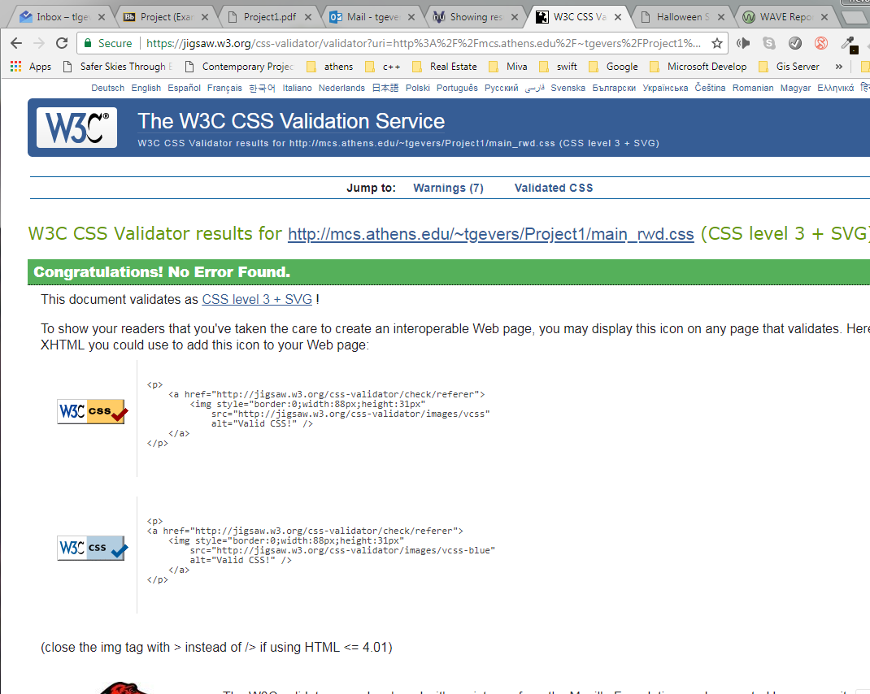

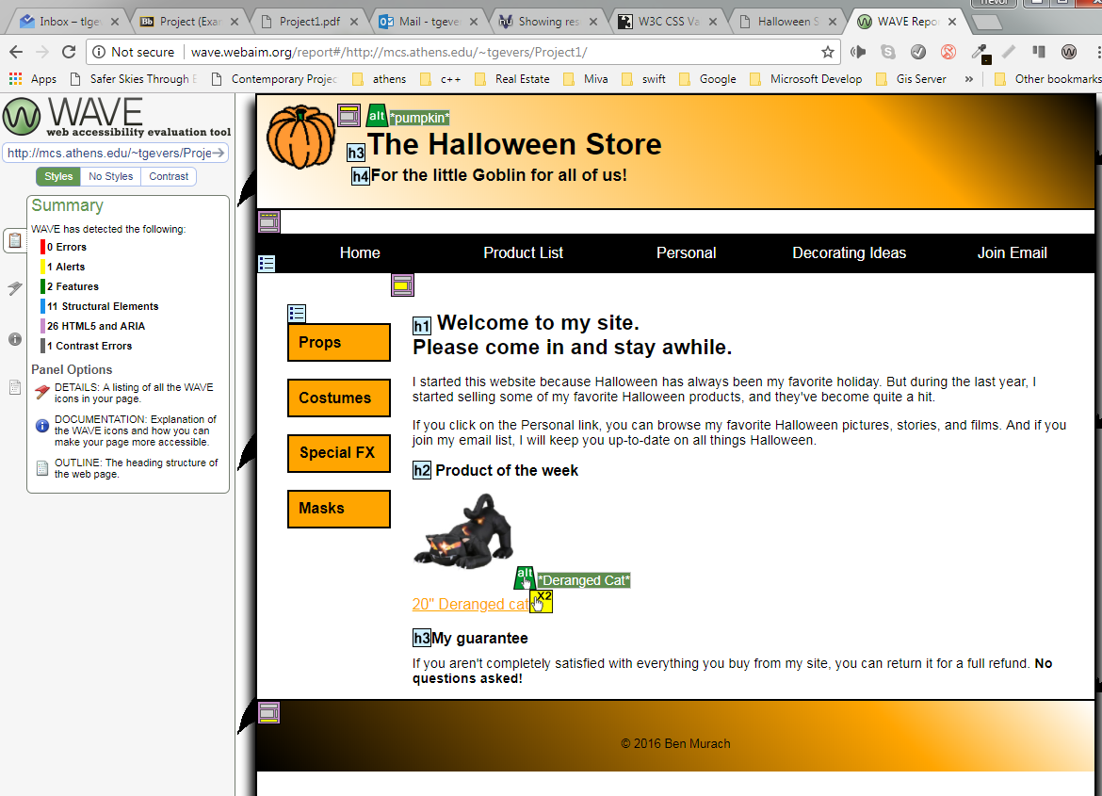

The summary included 0 Errors, 1 Alerts for a redundant link issue with an image and text as a link to the same page, 2 Features, 11 Structural Elements, 28 HTML5 and ARIA, and 1 contrast error for orange on a white background.